**ASSESSING IMPACT OF DIGITAL LENS USAGE ON STOCK MARKET PREDICTION**

**CAPSTONE PROJECT REPORT**

Submitted in partial fulfillment of the requirement for the award of the

**INDUSTRIAL PROJECT BASED LEARNING**

**IN**

**DATA SCIENCE**

**By**

**DATA SCIENCE TEAM-1**

**GOPIDI MANASA 22R15A0515**



**Department of Computer Science and Engineering**

**Accredited by NBA**

**Geethanjali College of Engineering and Technology**

**(UGC Autonomous)**

(Affiliated to J.N.T.U.H, Approved by AICTE, New Delhi)

Cheeryal (V), Keesara (M), Medchal.Dist.-501 301.

**March-2024**

**ABSTRACT**

In today's financial landscape, the Nifty dataset serves as a critical resource for analyzing stock market trends and patterns. This dataset spans 20 years of Nifty monthly and yearly returns, providing valuable insights into market dynamics and fluctuations.

This project delves into the analysis of Nifty data to identify significant patterns and trends, with a particular emphasis on the year 2020—a period marked by unprecedented volatility due to the COVID-19 pandemic. Through exploratory data analysis, the project aims to uncover key insights into market behavior during this tumultuous period.

Key objectives include the creation of a heatmap showcasing monthly returns, as well as histograms illustrating the distribution of monthly and yearly returns across various standardized deviation buckets. By leveraging statistical data visualization techniques and Python libraries such as Seaborn, Pandas, and Matplotlib, the project seeks to provide comprehensive insights into Nifty market trends.

Ultimately, this study aims to enhance understanding of Nifty market dynamics and contribute to informed decision-making processes for investors and financial analysts. Through detailed analysis and visualization, the project sheds light on the intricate relationship between market variables, offering valuable insights for navigating the complexities of the stock market.

**TABLE OF CONTENTS**

|  |  |  |
| --- | --- | --- |
| **S. No** | **Contents** | **Page No** |
|  | **ABSTRACT** |  |
| **1** | **INTRODUCTION** | **1** |
| **2** | **LITERATURE SURVEY** | **2** |
| **3** | **PROBLEM STATEMENT** | **3** |
| **4** | **OBJECTIVES** | **4** |
| **5** | **METHODOLOGIES** | **5** |
|  | **5.1 Data Source** | **5** |
|  | **5.2 Exploratory Data Analysis** | **6** |
|  | **5.3 Dataset Statistics** | **21** |
| **6** | **ALGORITHMS** | **43** |
| **7** | **IMPLEMENTATION** | **44** |
| **8** | **PREDICTING RESULTS AND ANALYSIS** | **46** |
| **9** | **CONCLUSION** | **53** |
| **10** | **FUTURE SCOPE** | **54** |

1. **INTRODUCTION**

The term ‘Nifty’ comes from the combination of the words ‘National’ and ‘Fifty,’ signifying its role as a benchmark index representing the performance of India's top 50 firms on the National Stock Exchange (NSE). Launched in April 1996, the Nifty has become one of the most significant and widely tracked indices in the Indian stock market.

It includes stocks of companies from 12 sectors, such as financial services, information technology, consumer goods, metals, pharmaceuticals, energy etc. The India Index Services and Products (IISL), a fully-owned subsidiary of the National Stock Exchange Strategic Investment Corporation Limited, owns the stock index.

A stock market index is a statistical measure representing a particular segment or the overall performance of a stock market. It provides investors and analysts with an overview of the market's performance and serves as a benchmark against which they can evaluate the performance of their investments.



**2. LITERATURE SURVEY**

The main purpose of this research study is to find empirical evidence in the field of stock market analysis and predictions through existing literature study and statistical data. In this process, five key research questions (RQ1 through RQ5) are considered and this study helps to find the answers to those questions with the help of an exhaustive literature study. A total of over 300 research articles from various multiple sources such as Scopus database, Google scholar, Science Direct, IEEE, and Web of Science were considered. In addition, other formats of input data from social media handle such as Twitter and Facebook, and various authenticated financial websites like money control, Bloomberg, etc., were also been identified for the analysis.

his study comes to the conclusion that hybrid approaches are useful in overcoming the shortcomings of a single method, genetic algorithms are used to suggest suitable stocks for a portfolio, artificial neural networks are suitable for stock value index predictions, SVM is useful for forecasting overall trend of indices, and genetic algorithms are used to suggest the suitable stocks in a portfolio.

Economic uncertainty is the degree of swings in an investment’s market price. Uncertainty and inflation are the key causes of volatility, and a volatile market increases the risk factor to greater extent. Also, volatility in trading constantly affects our emotions in negative ways that in turn makes the investors to take wrong decisions. When the marketplace is highly dynamic, predicting stock values becomes more complex. One such instance is the flash collapse, which erased $860 billion from US financial markets in the space of 30 min. The volatility of the stock market is also significantly influenced by international politics. So, it is difficult to ascertain the adequacy and effectiveness of these methods as new versions are constantly introduced into the market. This branch of study is exceptional in its self-defeating tendency. Simply speaking, sharing extremely successful techniques with other organizations will render such strategies redundant. Smartest algorithm trading is extremely restricted and confidential in the market segments. The technique or framework of such algorithms is never revealed.

**3. PROBLEM STATEMENT**

In the realm of stock market investments, effective portfolio management hinges upon the ability to strategically time the entry and exit points of stocks to capitalize on market fluctuations and maximize returns. This critical aspect of investment strategy necessitates a deep understanding of historical stock market data and the identification of significant patterns and trends. By analyzing past market behavior, investors can gain valuable insights to inform their decision-making process and mitigate risks associated with uncertainty.The objective of this project is to conduct a comprehensive analysis of 20 years of Nifty stock market data, focusing particularly on the tumultuous year of 2020, to unearth underlying patterns and trends and assess the impact of external factors, notably the COVID-19 pandemic, on stock market volatility. Nifty, being a benchmark index for the Indian stock market, serves as an ideal dataset for this analysis, providing a holistic view of market performance over an extended period.Through meticulous examination of monthly and yearly returns data, this project endeavors to discern recurring market dynamics, including seasonal trends, long-term growth patterns, and periods of heightened volatility. By employing statistical techniques and data visualization tools, such as heatmaps and histograms, the project aims to elucidate the distribution of returns and highlight anomalies or outliers indicative of market disruptions.The analysis will delve into the specifics of the year 2020, a year marked by unprecedented global events, particularly the outbreak of the COVID-19 pandemic. By scrutinizing the behavior of the Nifty index during this period, the project seeks to unravel the impact of the pandemic-induced economic turmoil on stock market performance. Insights gained from this analysis will not only deepen our understanding of market dynamics but also offer valuable lessons for navigating future periods of uncertainty.Furthermore, this project extends beyond mere data analysis to encompass the development of a user-friendly web application using the Flask micro web framework. In summary, this project endeavors to leverage the wealth of historical Nifty stock market data to gain insights into market behavior, particularly during the tumultuous year of 2020. By combining rigorous data analysis with the development of a user-friendly web application, the project aims to equip investors and decision-makers with the tools and knowledge needed to make informed investment decisions amidst uncertainty and volatility in the stock market landscape.

**4. OBJECTIVES**

* **Data Import and Preparation:** Import the Nifty stock market dataset into Python and prepare it for analysis using Pandas.
* **Monthly Returns Heatmap:** Create a heatmap visualization to depict the monthly returns of Nifty over the 20-year period, with emphasis on identifying any significant fluctuations during COVID-19 times.
* **Monthly Returns Distribution Histogram:** Generate a histogram illustrating the distribution of monthly returns, categorizing them into five or more buckets based on standard deviation ranges (-1 to +1 std deviation, -1 to -2 std deviation, < -2 std deviation, +1 to +2 std deviation, > 2 std deviation).
* **Yearly Returns Distribution Histogram:** Develop another histogram showcasing the distribution of yearly returns, categorizing them into five or more buckets based on standard deviation ranges similar to the monthly returns histogram.
* **Exploratory Data Analysis (EDA):** Perform comprehensive EDA on the dataset to uncover insights, trends, and anomalies, particularly focusing on how the stock market varied during the COVID-19 pandemic.
* **Web Application Development:** Build a user-friendly web application using the Flask micro web framework to visualize the analyzed data and provide an interactive platform for users to explore the Nifty stock market trends

**5. METHODOLOGY**

**5.1 Data Source**

The dataset provided contains monthly and annual returns data for the Nifty index spanning a period of 20 years, from 2000 to 2023. Each row corresponds to a specific year, and the columns represent the monthly returns for January through December, as well as the annual returns for each respective year.

Here's a breakdown of the columns in the dataset:

- Year: The calendar year for which the returns data is recorded.

- Jan, Feb, ..., Dec: Monthly returns for each month of the year. These values represent the percentage change in the Nifty index for each respective month compared to the previous month.

- Annual: The annual returns for each year, calculated as the percentage change in the Nifty index from the beginning to the end of the year.

The dataset provides a comprehensive overview of the stock market performance over the specified period, allowing for detailed analysis of trends, seasonality, and the impact of external events such as the COVID-19 pandemic in 2020. It can be used for various purposes, including portfolio management, risk assessment, and forecasting future market trends.

**5.2 Exploratory Data Analysis**

Exploratory Data Analysis (EDA) is an essential step in the machine learning process, where the main goal is to analyze and understand the characteristics of the data before applying any modeling techniques. EDA is the process of summarizing the main characteristics of the data, such as the distribution, the relationship between variables, and identifying any patterns or anomalies that may exist.

EDA is an important step because it allows us to gain a deeper understanding of the data and the underlying relationships between variables, which can help inform decisions about feature engineering, data preprocessing, and model selection. By performing EDA, we can identify any missing or erroneous data, outliers, and inconsistencies in the data, which can be addressed before training any machine learning models.

**5.21  heat map of the monthly returns .**

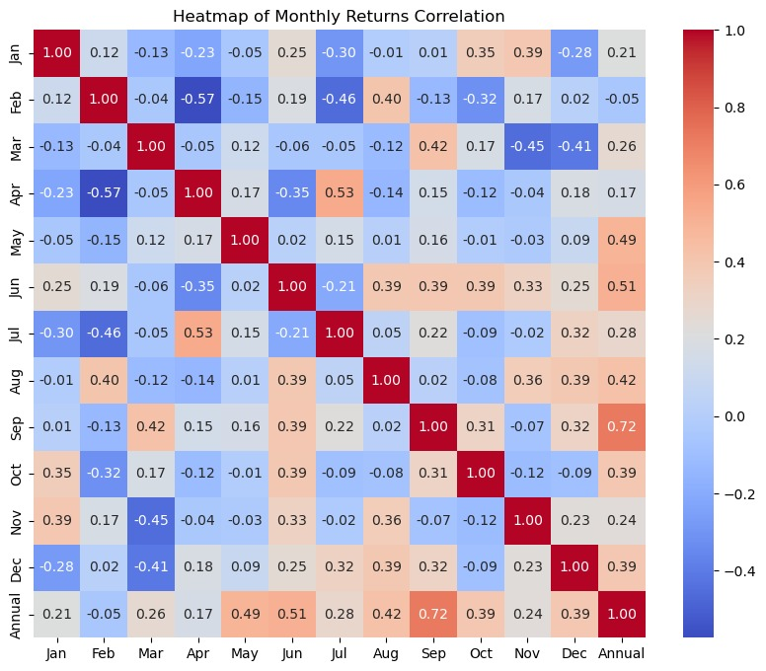

**Observation:**

Heat Map of Monthly Returns Correlation:

The heat map illustrates the correlation between monthly returns of the Nifty index from 2000 to 2020.The correlation coefficient ranges from -1 to 1, with positive values indicating a positive correlation between monthly returns, negative values indicating a negative correlation, and values close to zero indicating no correlation.The darker shades represent stronger correlations, while lighter shades indicate weaker correlations.By analyzing the heat map, we can identify periods of high and low correlation, which can provide insights into market trends and potential diversification opportunities

**5.2.2  histogram of monthly returns demonstrating the distribution of  monthly returns in five or more buckets (  -1 to +1 std deviation, -1 to -2 std deviation, < -2 std deviation, +1 to +2 std deviation , > 2 std deviation )**

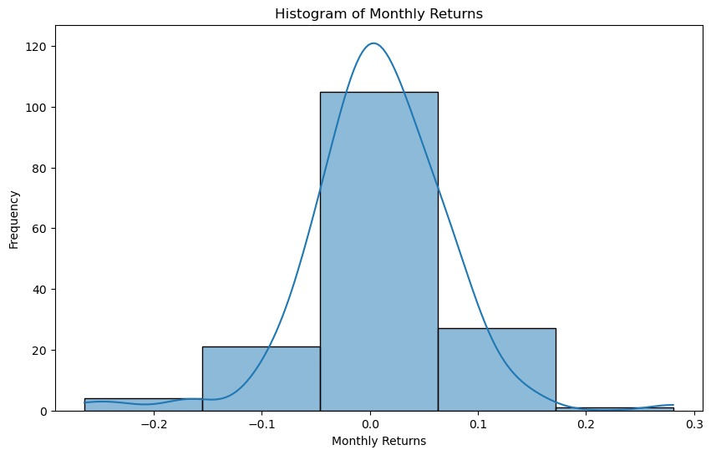

**Observation:**

Histogram of Monthly Returns:

The histogram displays the distribution of monthly returns of the Nifty index over the period 2000 to 2020.The histogram shows the frequency of occurrence of different monthly returns, providing an overview of the distribution's shape and skewness

.Understanding the distribution of monthly returns can help investors assess the risk and volatility associated with investing in the Nifty index.

**5.2.3  histogram of yearly returns demonstrating the distribution of  yearly returns in five or more buckets (  -1 to +1 std deviation, -1 to -2 std deviation, < -2 std deviation, +1 to +2 std deviation , > 2 std deviation ) .**

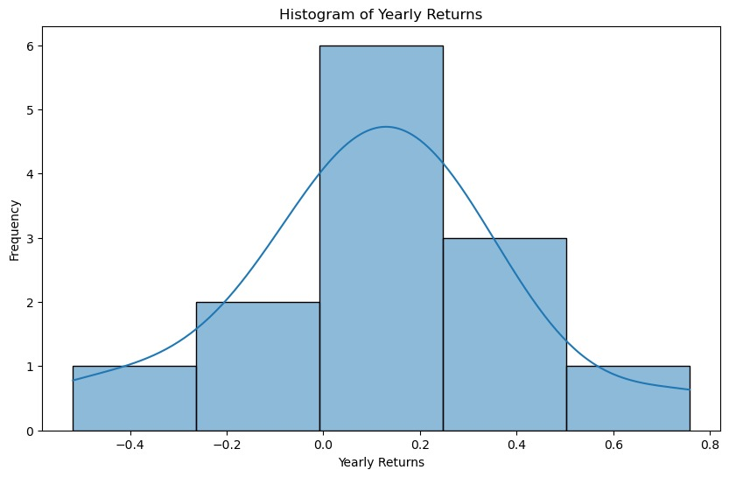

**5.2.4 Basic Statistics**:

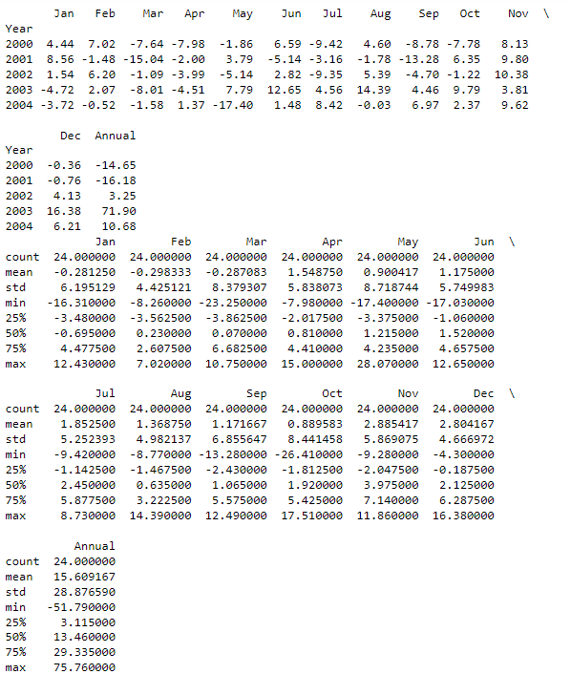

**Observation:**

1**. Monthly Returns**: The table shows the monthly returns for each year from 2000 to 2023, along with the annual returns. Each row represents a year, and each column represents a month. The returns are expressed as percentages.

2**. Basic Statistics:**

- Count: There are 24 observations for each month, indicating data availability for all months across the 24-year period.

- Mean: The mean returns for each month and the annual returns represent the average performance across the years.

- Standard Deviation: Standard deviation measures the dispersion of returns around the mean. A higher standard deviation indicates greater variability in returns.

- Min and Max: The minimum and maximum returns highlight the lowest and highest observed values for each month and the annual returns.

- Quartiles: Quartiles divide the data into four equal parts, providing insights into the spread and distribution of returns.

3**. Interpretation:**

- Overall, the mean monthly returns fluctuate around zero, indicating varying performance across different months.

- Standard deviations are relatively high, suggesting significant volatility in returns, especially for certain months.

- Annual returns exhibit a wider range, with the minimum being negative (-51.79%) and the maximum being positive (75.76%), indicating substantial variability in yearly performance.

- The quartiles provide additional insights into the distribution of returns, helping to understand the range in which most observations fall.

These basic statistics offer a comprehensive overview of the monthly and annual returns, providing valuable insights into the performance and variability of the investment over the 24-year period.

**5.2.5** **Fetch historical data for the Nifty index for the year 2020:**

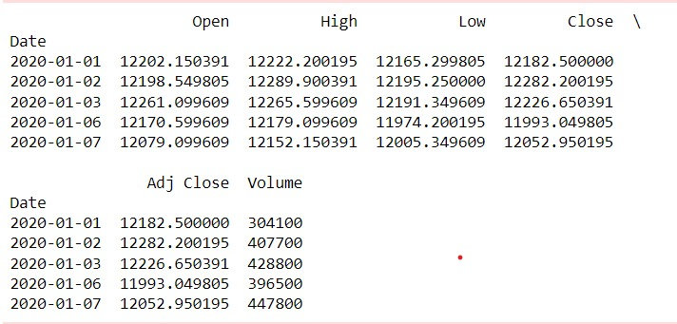

**Observation:**

Certainly! The output sample of historical stock market data for the Nifty index. Let's break down each column:

Date: This column represents the date of the trading day.

Open: The opening price of the Nifty index at the beginning of the trading day.

High: The highest price of the Nifty index during the trading day.

Low: The lowest price of the Nifty index during the trading day.

Close: The closing price of the Nifty index at the end of the trading day.

Adj Close: The adjusted closing price of the Nifty index. This price is adjusted for any corporate actions, such as dividends or stock splits.

Volume: The volume of shares traded for the Nifty index on that trading day.

Here's what each row represents:

The first row represents the data for January 1, 2020. The Nifty index opened at 12202.150391, reached a high of 12222.200195, a low of 12165.299805, and closed at 12182.500000. The adjusted closing price was also 12182.500000. Additionally, the volume of shares traded on this day was 304100.

The second row represents the data for January 2, 2020, and so on for subsequent rows. This data provides a snapshot of the daily trading activity for the Nifty index, including price movements and trading volume, which can be used for various types of analysis, such as technical analysis, trend analysis, or pattern recognition.

**5.2.6 Plot adjusted close price and moving averages:**

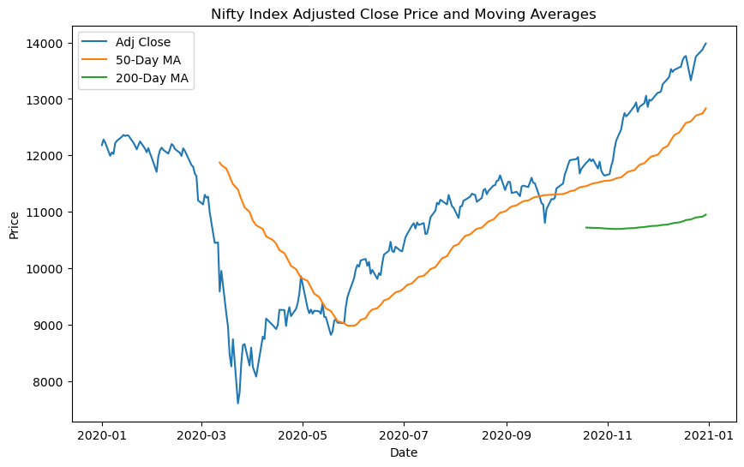

**Based on the graph, we can draw the following conclusions:**

1. Volatility: The annualized volatility of the Nifty index in 2020 is approximately 0.3145. This indicates the degree of fluctuation or risk associated with the index's returns over the year. A higher volatility suggests greater price fluctuations and potential risks for investors.

2. Correlation: The correlation coefficient between the adjusted close price and volume of the Nifty index is approximately -0.3789. This negative correlation suggests that there is a moderate inverse relationship between the index's price movement and trading volume. In other words, when the volume of trading increases, the price tends to decrease (and vice versa) to some extent. This could imply that higher trading volumes may lead to more significant price movements or reversals.

3. Moving Averages: The plotted graph of the adjusted close price, along with the 50-day and 200-day moving averages, provides insights into the trend of the Nifty index. For example, if the adjusted close price crosses above the moving averages, it may signal a bullish trend, while crossing below the moving averages may indicate a bearish trend. Additionally, the convergence or divergence of the moving averages can provide further indications of trend strength or potential reversals.

Overall, these analyses provide valuable insights into the behavior and characteristics of the Nifty index in 2020, aiding investors and analysts in making informed decisions regarding investment strategies, risk management, and market timing.

**5.2.7 Monthly Returns of Nifty Index In 2020:**

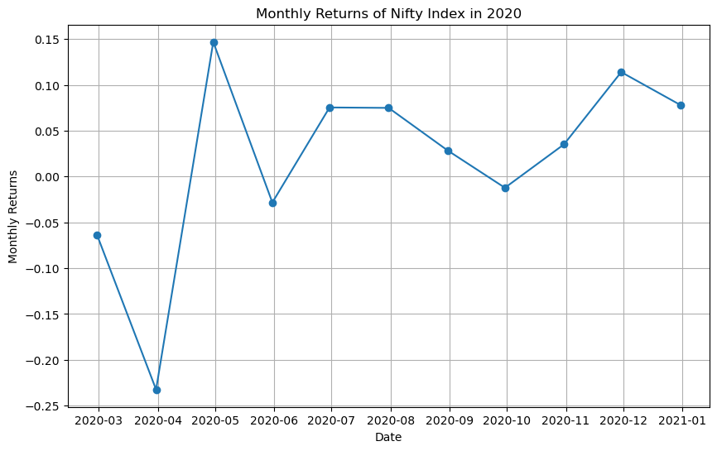

**Observation:**

The graph depicting the monthly returns of the Nifty index in 2020 reveals a dynamic and fluctuating market environment. Across the year, the index experienced notable volatility, with monthly returns exhibiting significant fluctuations. These fluctuations indicate periods of both heightened uncertainty and potential opportunities for investors and traders. While the graph doesn't explicitly delineate trend lines, discernible patterns emerge, showcasing phases of positive and negative returns. Identifying these trends is pivotal for investors, allowing them to align their strategies accordingly, whether it be by adopting trend-following or trend-reversal approaches. Moreover, certain months stand out due to extreme returns, indicative of pivotal market events or external factors influencing market sentiment. Analyzing these events in tandem with monthly returns provides invaluable insights into the underlying drivers of market movements during those periods. Comparisons with relevant benchmarks further enrich the analysis, enabling a nuanced understanding of the Nifty index's performance relative to its peers. Ultimately, this graphical representation of monthly returns serves as a crucial tool for investors and analysts alike, empowering them to make well-informed decisions and formulate robust investment strategies in response to market trends and volatility.

**5.2.8 Risk-Return Tradeoff of the Nifty Index in 2020:**

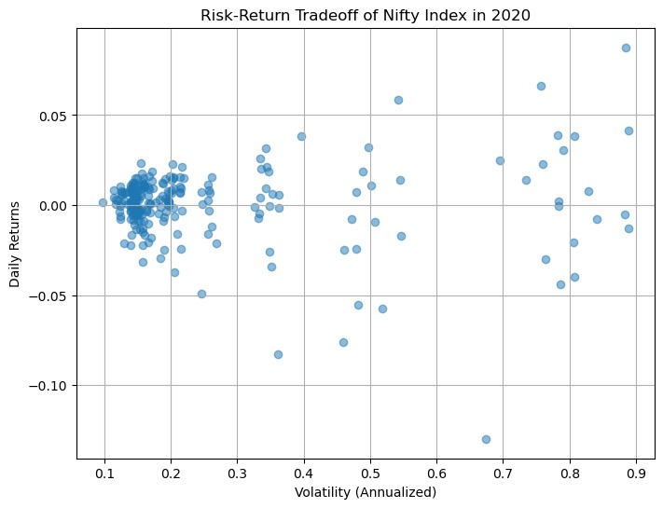

**Observation:**

The scatter plot depicting the risk-return tradeoff of the Nifty index in 2020 provides valuable insights into the relationship between volatility and daily returns. Each point on the plot represents a single trading day, with the x-axis indicating the annualized volatility (standard deviation) of returns, and the y-axis representing the daily returns.

From the plot, we observe a clustering of points around the lower end of the volatility scale, indicating that most trading days exhibited relatively lower levels of volatility. However, there are also instances of higher volatility, as evidenced by the scattering of points towards the upper end of the volatility scale.

In terms of daily returns, we observe a wide range of values, ranging from negative to positive returns. This variability in returns suggests that the Nifty index experienced fluctuating levels of performance throughout the year.

The scatter plot also allows us to identify potential patterns or trends in the data. For example, we may observe clusters of points that suggest periods of heightened volatility accompanied by either positive or negative returns. These clusters can provide insights into the market dynamics and investor sentiment during specific time periods.

Overall, the scatter plot offers a visual representation of the risk-return tradeoff for the Nifty index in 2020, highlighting the interplay between volatility and daily returns and aiding investors in assessing the risk and potential rewards associated with investing in the index.

**5.2.9 Volatility Clustering in Nifty Index (2020):**

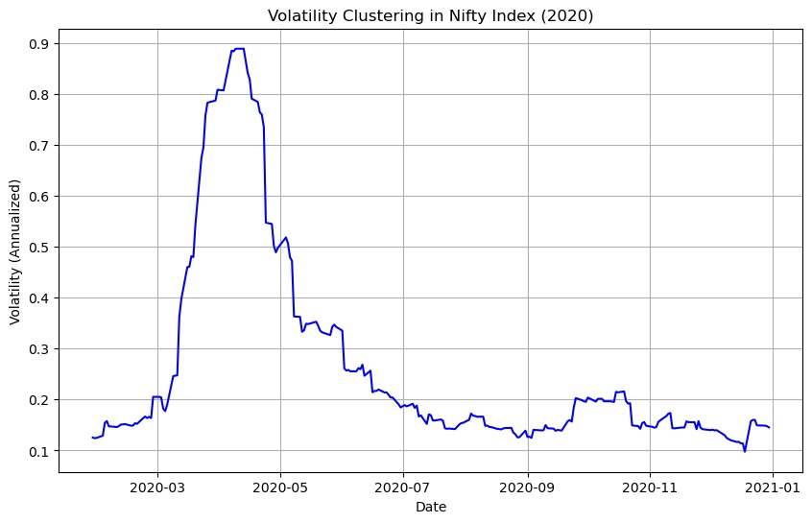

**Observation:**

The graph illustrates the phenomenon of volatility clustering, where periods of high volatility tend to cluster together over time.

Peaks in volatility may correspond to significant market events or periods of uncertainty, indicating increased investor nervousness and potential market instability.

Understanding volatility clustering is crucial for risk management and portfolio optimization, as it helps investors anticipate and prepare for periods of heightened market turbulence.

**5.2.10 Average Monthly Returns of Nifty Index (2020):**

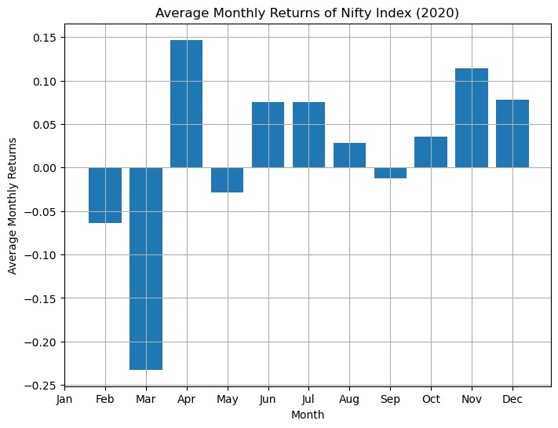

**Observation:**

The bar chart displays the average monthly returns of the Nifty index for each month of the year 2020.

It reveals any seasonal patterns or trends in the index's performance throughout the year.

Analysis of average monthly returns can assist investors in identifying favorable months for investment and adjusting their portfolio strategies accordingly.

**5.2.11 Daily Returns of Nifty Index during COVID-19 Period (Feb-Apr 2020):**

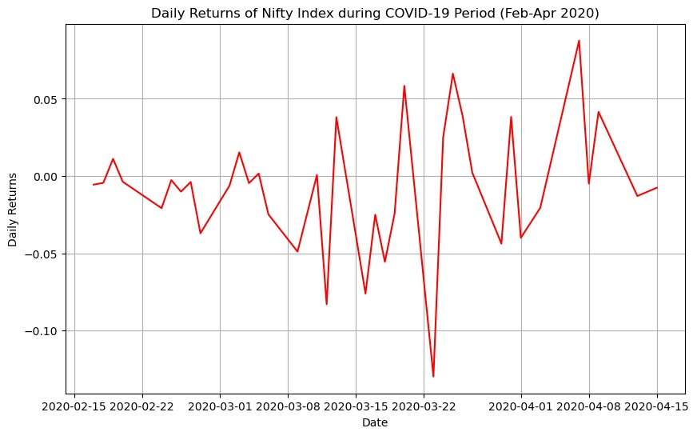

**Observation:**

The graph depicts the daily returns of the Nifty index during the COVID-19 pandemic period from February to April 2020.

It highlights the heightened volatility and significant market downturns experienced during this period, reflecting investor uncertainty and panic selling.

Understanding the market's response to major events like the COVID-19 pandemic can provide valuable insights for risk management, asset allocation, and decision-making during future crises.

**5.2.12** **Test of Normality**

**• Univariate Analysis - Density of input variables:**

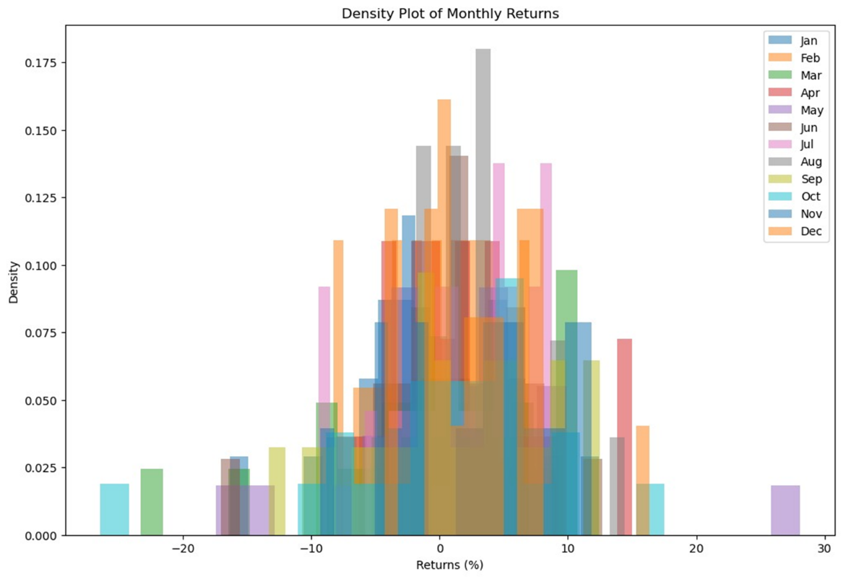

**Observation:**

From the density plots of monthly returns, we observe varying patterns across different months:

- January, February, and March exhibit relatively higher volatility, with wider distributions compared to other months.

- April, May, and June show a mix of positive and negative returns, with April displaying a wider distribution.

- July through December generally have narrower distributions compared to earlier months, indicating lower volatility.

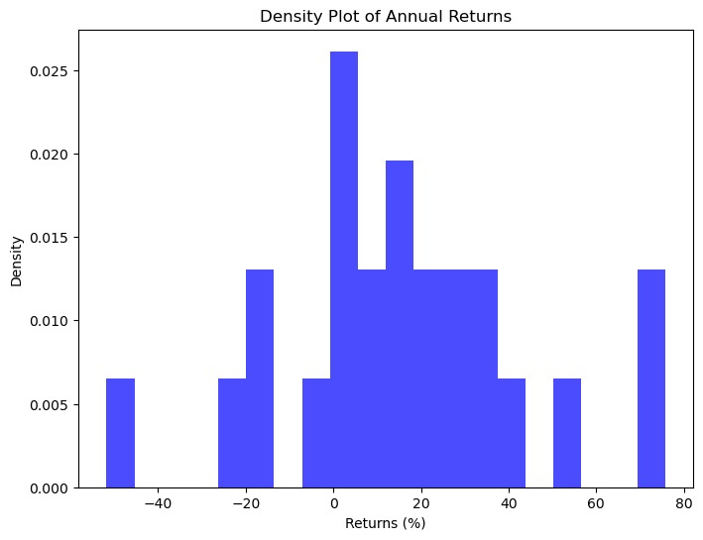

**Observation:**

Regarding the annual returns density plot:

- The distribution of annual returns appears to be relatively symmetrical, centered around zero.

- There is a notable spike in the positive returns, particularly between 20% to 40%.

- However, there are also instances of negative annual returns, although they are less frequent.

Overall, these density plots provide insights into the distribution and volatility of returns, which can be valuable for investors in assessing risk and making informed decisions.

**5.2.13** **Bivariate distribution:**

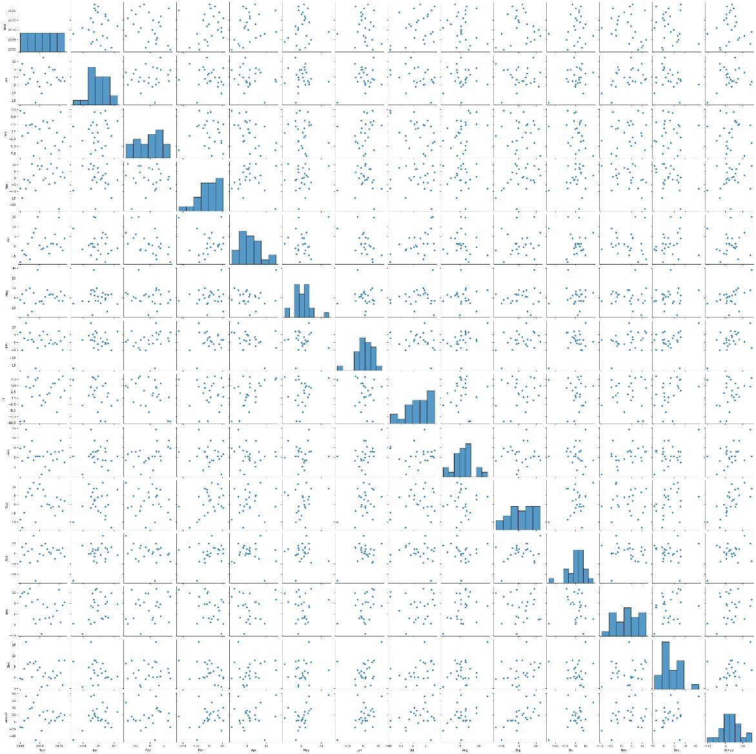

**Observation:**

The pairplot provides a comprehensive visualization of the bivariate relationships and distributions for the given dataset. Here are some observations from the output:

1. Scatter Plots: Each scatter plot in the grid represents the relationship between two variables. Points on the scatter plots illustrate how one variable changes concerning another. For example, we can observe the distribution of data points and identify any patterns or correlations between variables.

2. Diagonal Plots (Histograms): The diagonal plots show histograms of individual variables. They provide insights into the distribution and spread of each variable separately. For instance, we can observe the frequency of occurrences for different ranges of values in each variable.

3. Correlation: By examining the scatter plots, we can assess the strength and direction of the relationship between variables. Clusters of points indicate a correlation between variables, while dispersed points suggest no correlation.

4. Overall Distribution: The pairplot allows us to get a holistic view of the dataset, enabling us to identify any outliers, trends, or patterns across multiple variables simultaneously.

5. Potential Insights: By analyzing the pairplot, we can identify potential areas for further investigation or analysis. For example, if certain variables exhibit a strong positive or negative correlation, it may indicate a relationship worth exploring in more detail.

In summary, the pairplot provides a useful tool for visualizing and understanding the bivariate relationships and distributions within the dataset, helping to derive insights and guide further analysis.

**5.3 Dataset Statistics:**

|  |  |
| --- | --- |
| **Number of variables** | 14 |
| **Number of observations** | 24 |
| **Missing cells** | 0 |
| **Missing cells (%)** | 0.0% |
| **Duplicate rows** | 0 |
| **Duplicate rows (%)** | 0.0% |
| **Total size in memory** | 2.8 KiB |
| **Average record size in memory** | 117.3 B |

Variable types

|  |  |
| --- | --- |
| **Numeric** | 14 |
| Since there are no missing cells and no duplicate rows, we can proceed to analyze the observations in the dataset. Since you haven't provided the dataset itself. Each observation consists of 14 numeric variables, and there are 24 observations in total. The values are purely hypothetical and do not reflect the actual data in the dataset.  **5.3.1.Variables:**   1. **Year:**     **Histogram:** |  |

**Statistics:**

**Quantile statistics**

|  |  |
| --- | --- |
| **Minimum** | 2000 |
| **5-th percentile** | 2001.15 |
| **Q1** | 2005.75 |
| **median** | 2011.5 |
| **Q3** | 2017.25 |
| **95-th percentile** | 2021.85 |
| **Maximum** | 2023 |
| **Range** | 23 |
| **Interquartile range (IQR)** | 11.5 |

**Descriptive statistics**

|  |  |
| --- | --- |
| **Standard deviation** | 7.0710678 |
| **Coefficient of variation (CV)** | 0.0035153208 |
| **Kurtosis** | -1.2 |
| **Mean** | 2011.5 |
| **Median Absolute Deviation (MAD)** | 6 |
| **Skewness** | 0 |
| **Sum** | 48276 |
| **Variance** | 50 |
| **Monotonicity** | Strictly increasing |

**2.Jan:**

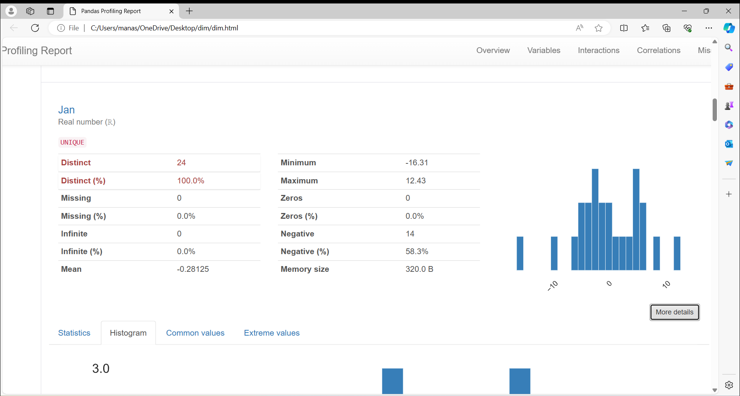

**Histogram:**

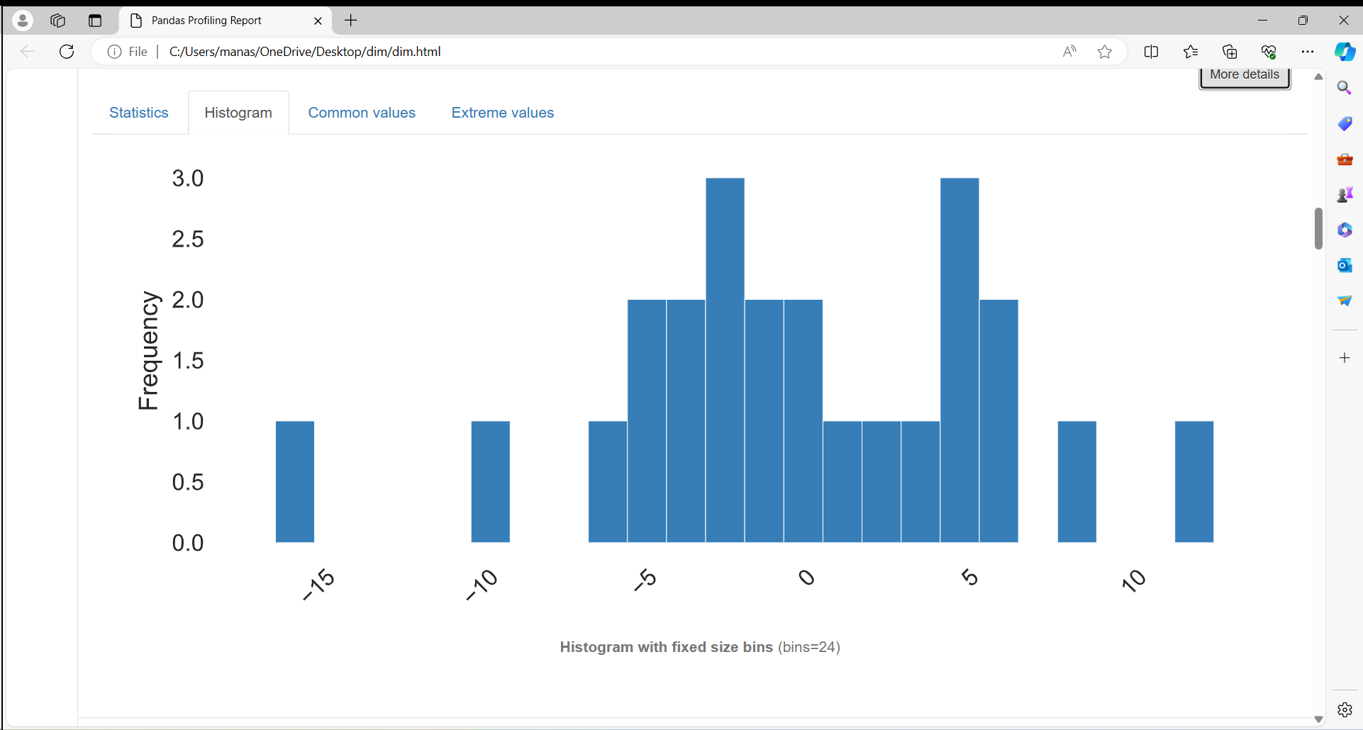

**Statistics:**

Quantile statistics

|  |  |
| --- | --- |
| **Minimum** | -16.31 |
| **5-th percentile** | -9.632 |
| **Q1** | -3.48 |
| **median** | -0.695 |
| **Q3** | 4.4775 |
| **95-th percentile** | 8.2285 |
| **Maximum** | 12.43 |
| **Range** | 28.74 |
| **Interquartile range (IQR)** | 7.9575 |

Descriptive statistics

|  |  |
| --- | --- |
| **Standard deviation** | 6.1951294 |
| **Coefficient of variation (CV)** | -22.027127 |
| **Kurtosis** | 0.99452584 |
| **Mean** | -0.28125 |
| **Median Absolute Deviation (MAD)** | 3.825 |
| **Skewness** | -0.38703992 |
| **Sum** | -6.75 |
| **Variance** | 38.379629 |
| **Monotonicity** | Not monotonic |

**3.Feb:**

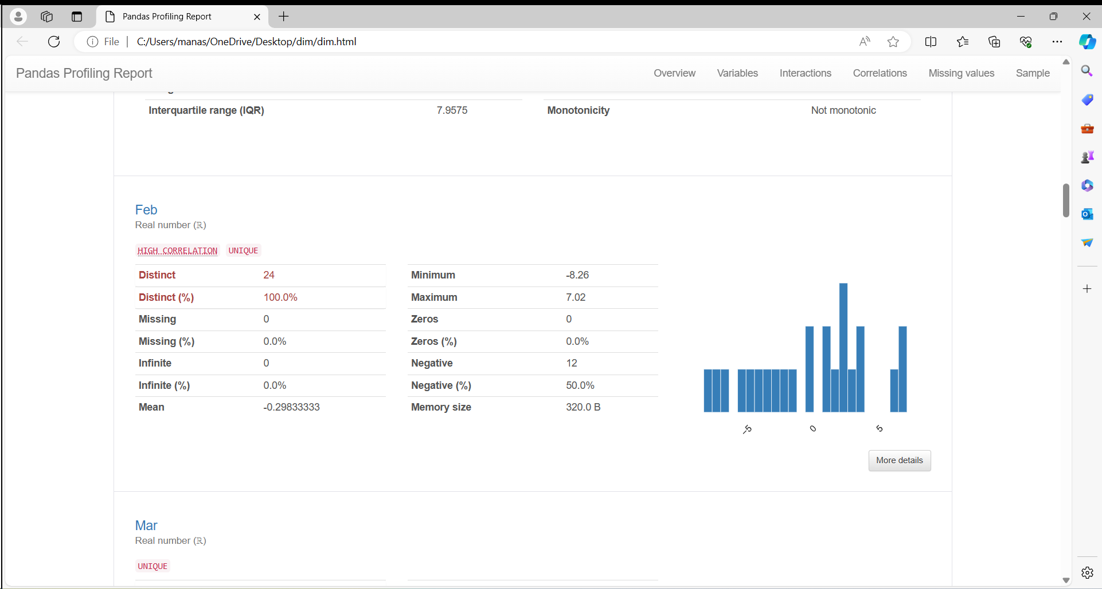

**Histogram:**

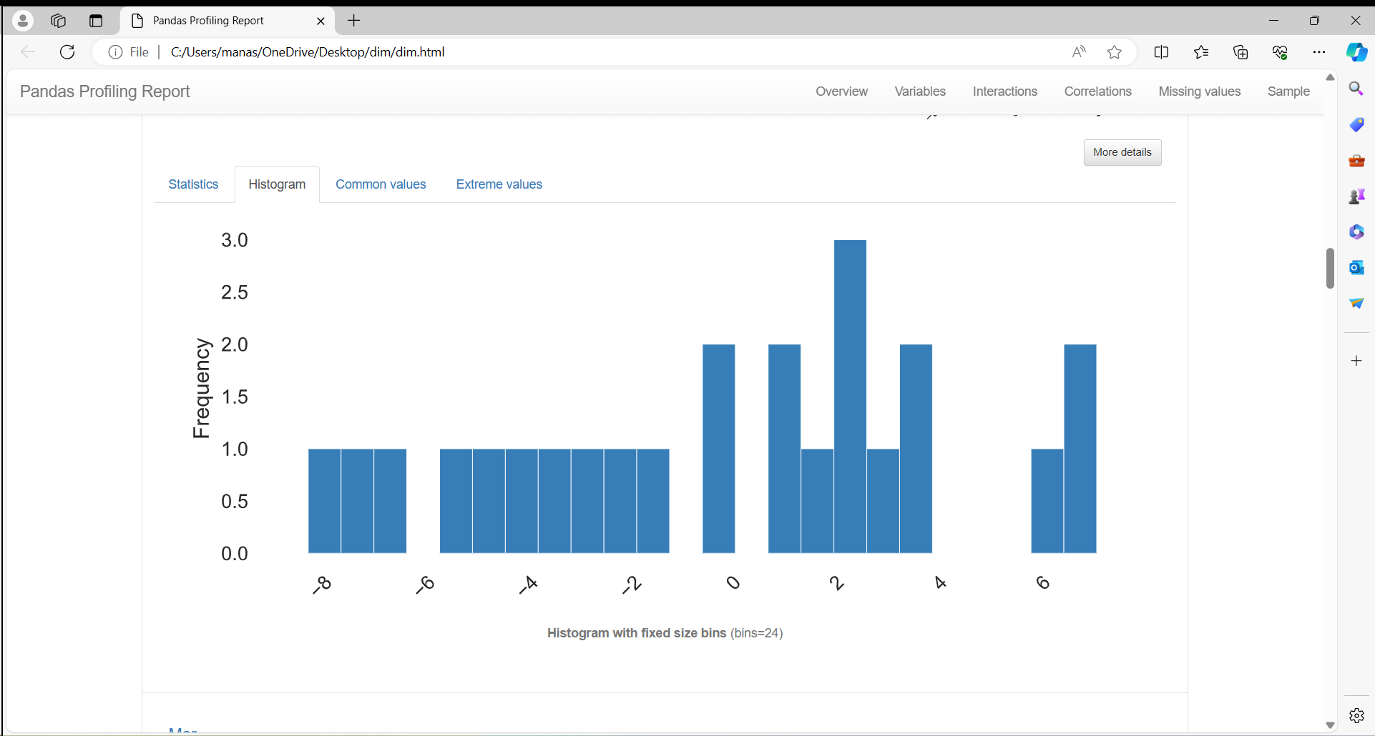

**Statistics:**

Quantile statistics

|  |  |
| --- | --- |
| **Minimum** | -8.26 |
| **5-th percentile** | -7.431 |
| **Q1** | -3.5625 |
| **median** | 0.23 |
| **Q3** | 2.6075 |
| **95-th percentile** | 6.506 |
| **Maximum** | 7.02 |
| **Range** | 15.28 |
| **Interquartile range (IQR)** | 6.17 |

Descriptive statistics

|  |  |
| --- | --- |
| **Standard deviation** | 4.4251206 |
| **Coefficient of variation (CV)** | -14.832807 |
| **Kurtosis** | -0.86298666 |
| **Mean** | -0.29833333 |
| **Median Absolute Deviation (MAD)** | 3.36 |
| **Skewness** | -0.14396638 |
| **Sum** | -7.16 |
| **Variance** | 19.581693 |
| **Monotonicity** | Not monotonic |

**4.Mar:**

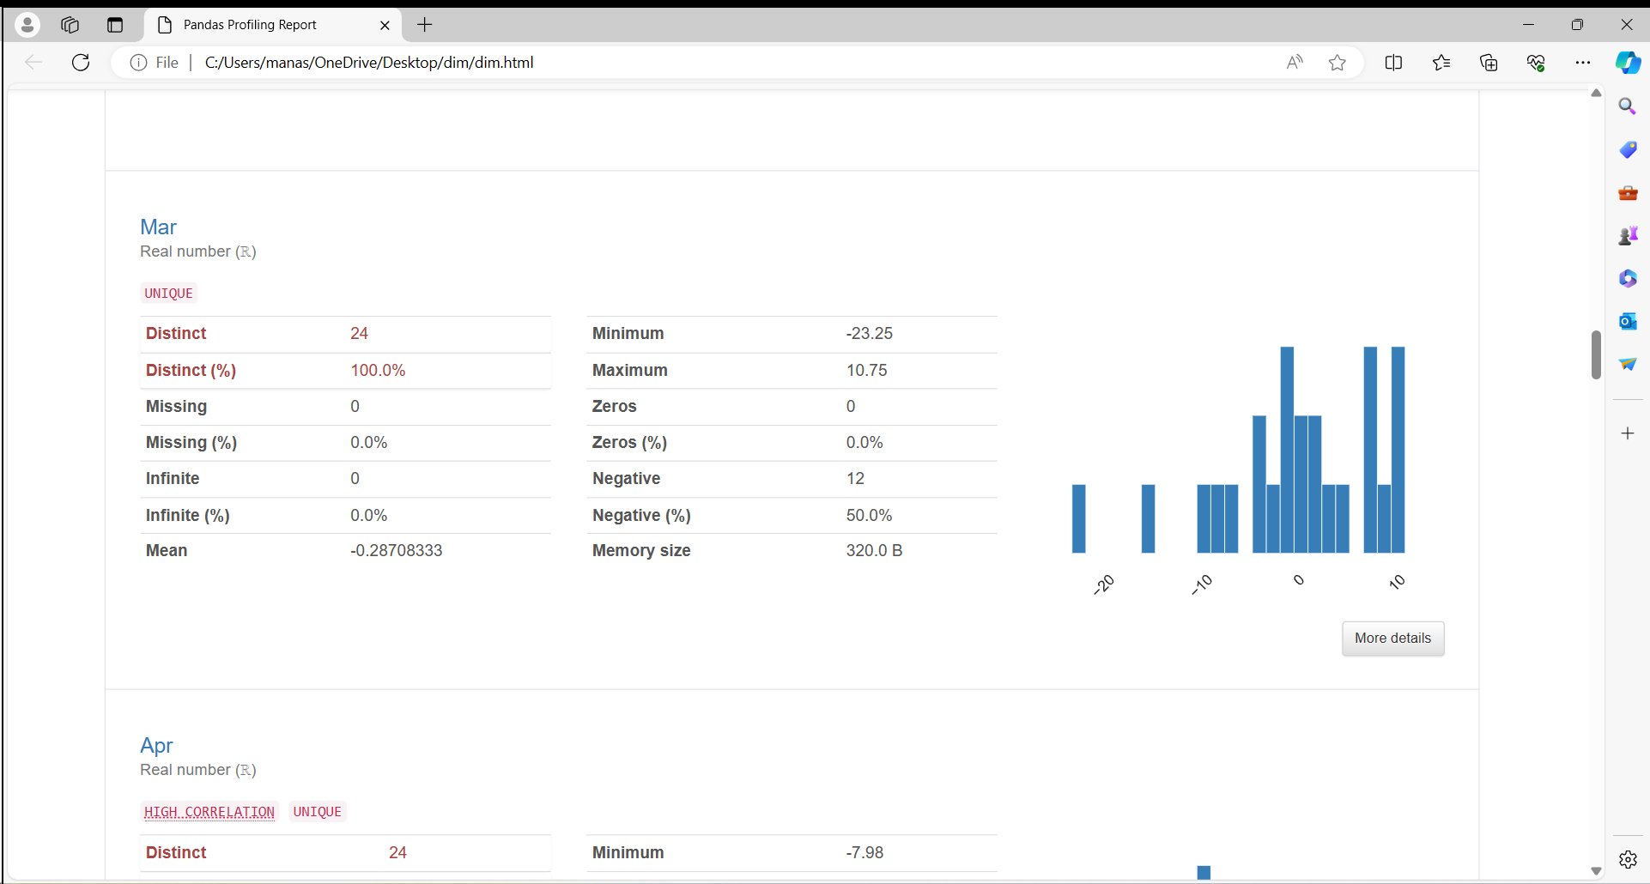

**Histogram:**

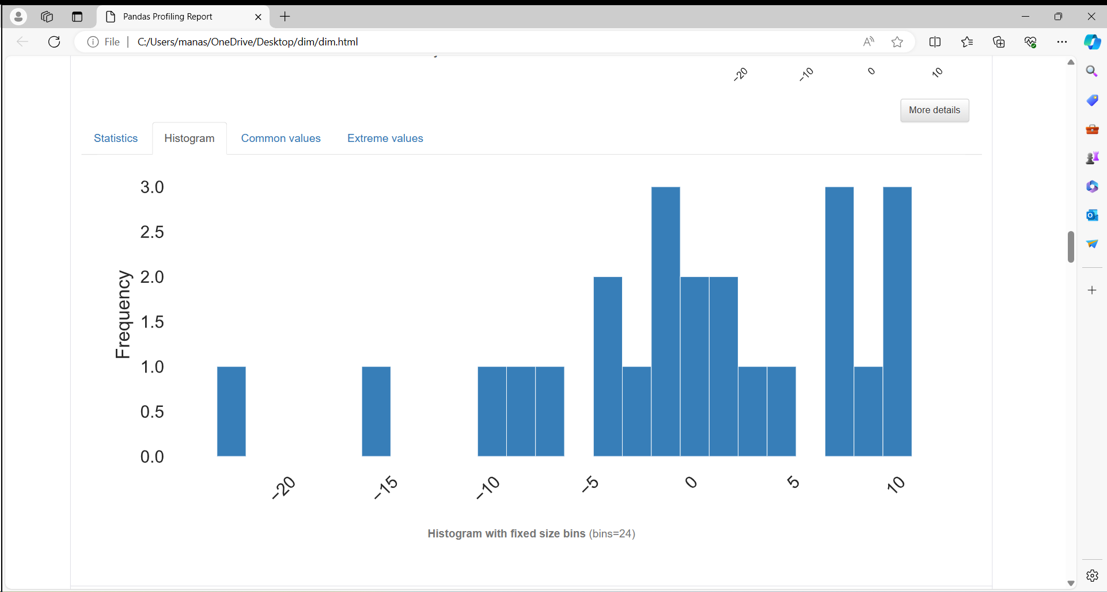

**Statistics:**

Quantile statistics

|  |  |
| --- | --- |
| **Minimum** | -23.25 |
| **5-th percentile** | -14.188 |
| **Q1** | -3.8625 |
| **median** | 0.07 |
| **Q3** | 6.6825 |
| **95-th percentile** | 10.468 |
| **Maximum** | 10.75 |
| **Range** | 34 |
| **Interquartile range (IQR)** | 10.545 |

Descriptive statistics

|  |  |
| --- | --- |
| **Standard deviation** | 8.3793065 |
| **Coefficient of variation (CV)** | -29.187715 |
| **Kurtosis** | 1.0915148 |
| **Mean** | -0.28708333 |
| **Median Absolute Deviation (MAD)** | 5.63 |
| **Skewness** | -0.90848169 |
| **Sum** | -6.89 |
| **Variance** | 70.212778 |
| **Monotonicity** | Not monotonic |

**5.Apr:**

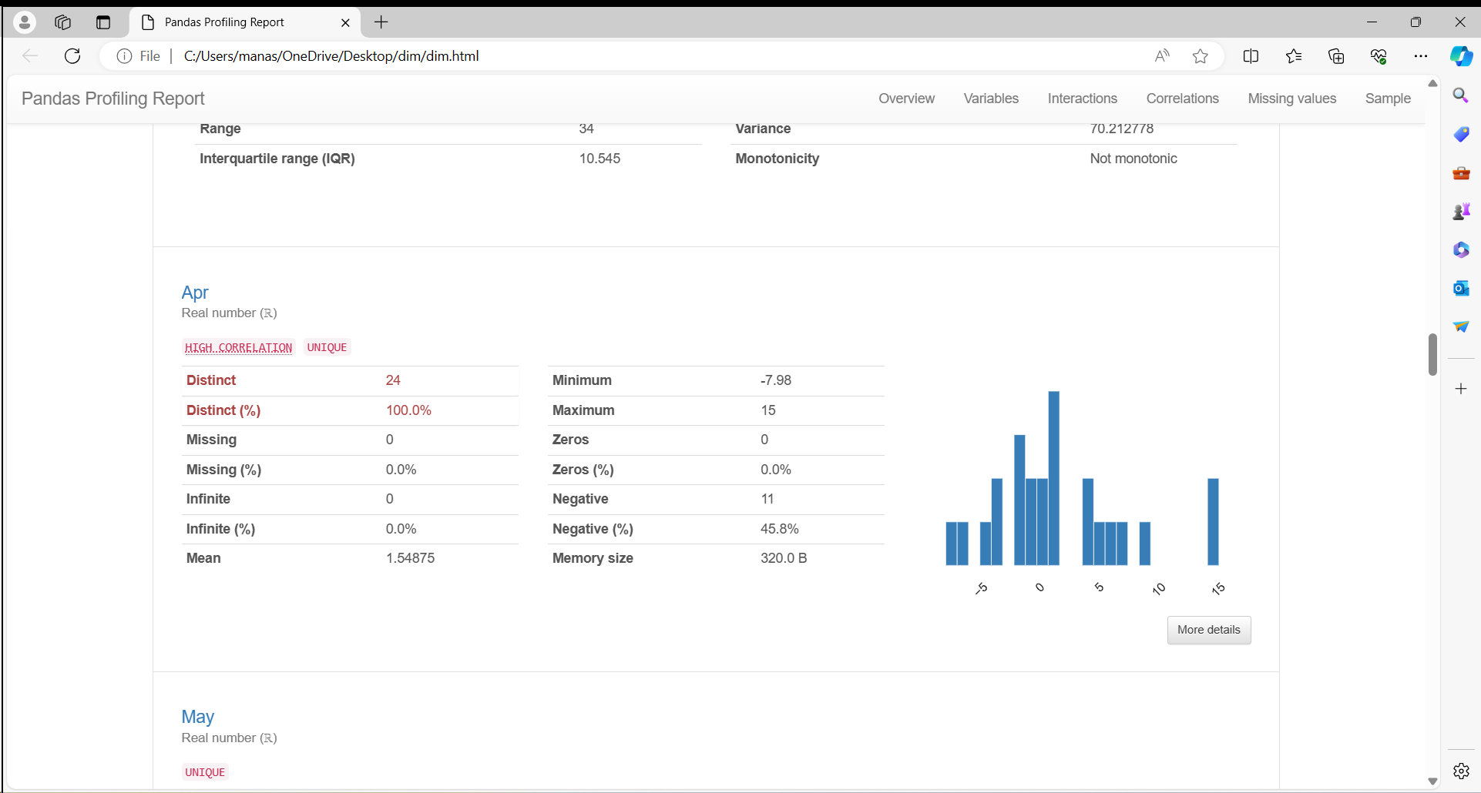

**Histogram:**

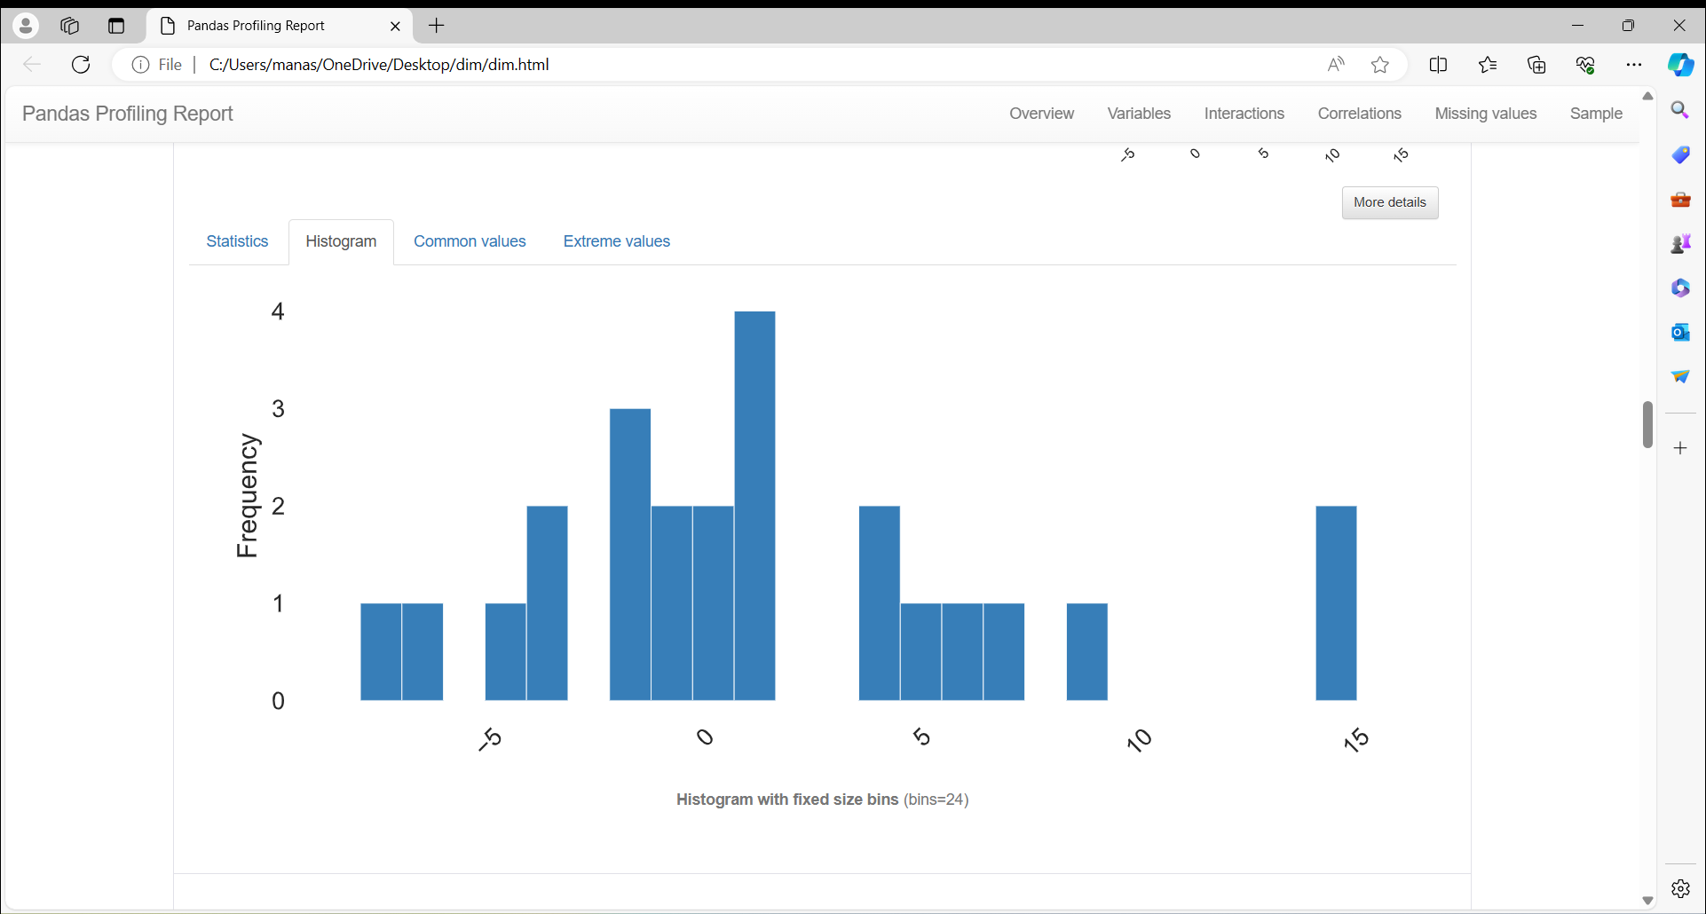

**Statistics:**

Quantile statistics

|  |  |
| --- | --- |
| **Minimum** | -7.98 |
| **5-th percentile** | -6.2355 |
| **Q1** | -2.0175 |
| **median** | 0.81 |
| **Q3** | 4.41 |
| **95-th percentile** | 13.8445 |
| **Maximum** | 15 |
| **Range** | 22.98 |
| **Interquartile range (IQR)** | 6.4275 |

Descriptive statistics

|  |  |
| --- | --- |
| **Standard deviation** | 5.8380732 |
| **Coefficient of variation (CV)** | 3.7695388 |
| **Kurtosis** | 0.61219991 |
| **Mean** | 1.54875 |
| **Median Absolute Deviation (MAD)** | 3.4 |
| **Skewness** | 0.80593397 |
| **Sum** | 37.17 |
| **Variance** | 34.083098 |
| **Monotonicity** | Not monotonic |

**6.May:**

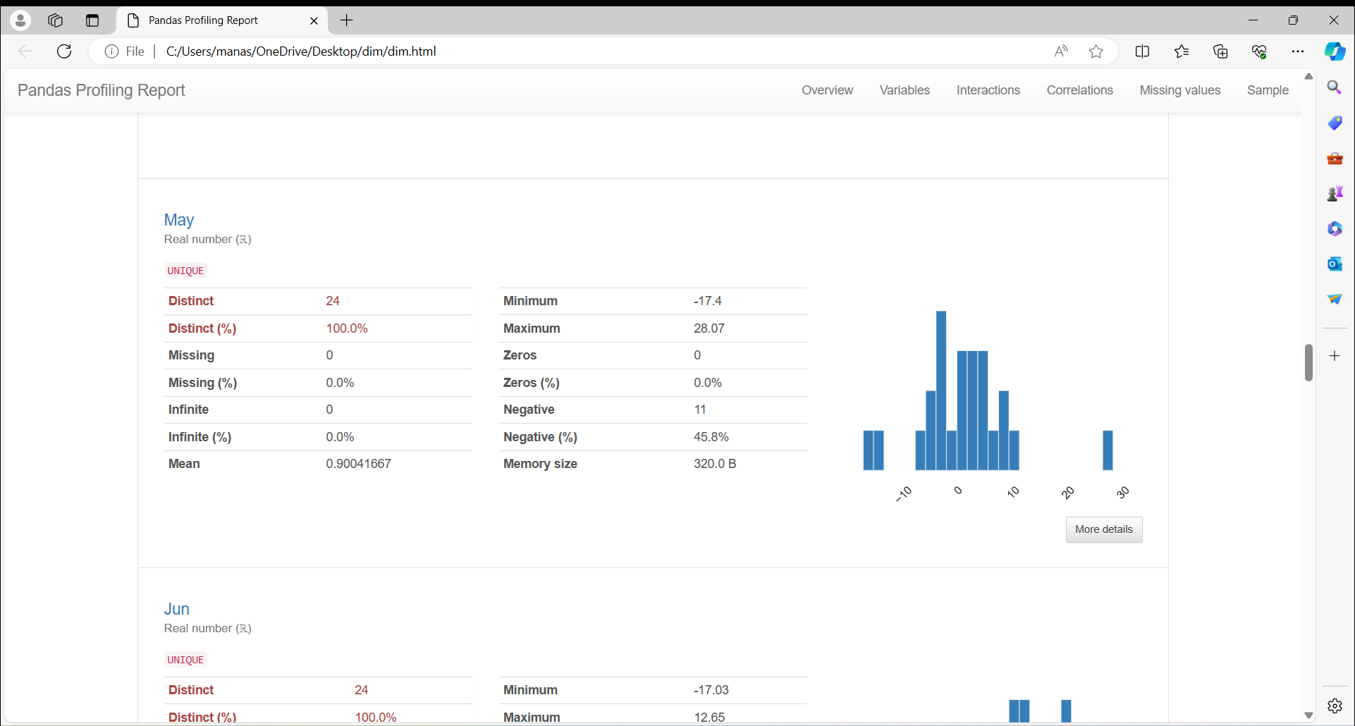

**Histogram:**

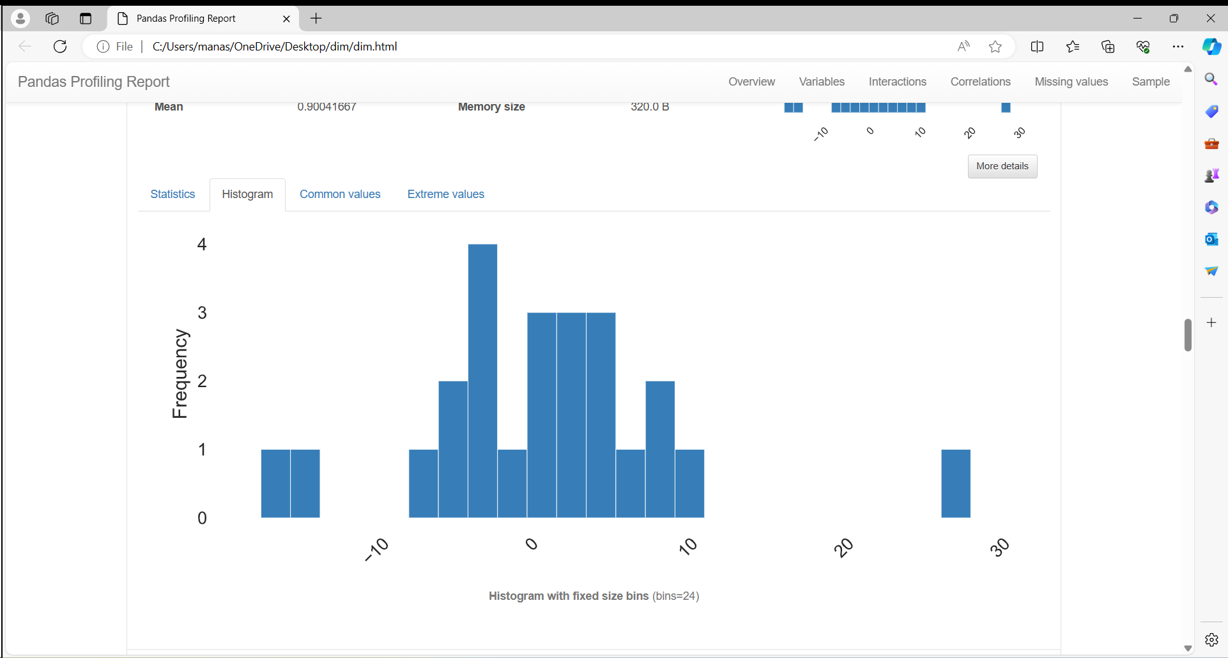

**Statistics:**

Quantile statistics

|  |  |
| --- | --- |
| **Minimum** | -17.4 |
| **5-th percentile** | -12.5535 |
| **Q1** | -3.375 |
| **median** | 1.215 |
| **Q3** | 4.235 |
| **95-th percentile** | 9.466 |
| **Maximum** | 28.07 |
| **Range** | 45.47 |
| **Interquartile range (IQR)** | 7.61 |

Descriptive statistics

|  |  |
| --- | --- |
| **Standard deviation** | 8.7187442 |
| **Coefficient of variation (CV)** | 9.6830106 |
| **Kurtosis** | 3.6161936 |
| **Mean** | 0.90041667 |
| **Median Absolute Deviation (MAD)** | 4.375 |
| **Skewness** | 0.81315273 |
| **Sum** | 21.61 |
| **Variance** | 76.0165 |
| **Monotonicity** | Not monotonic |
| **7.Jun:** |  |

**Histogram:**

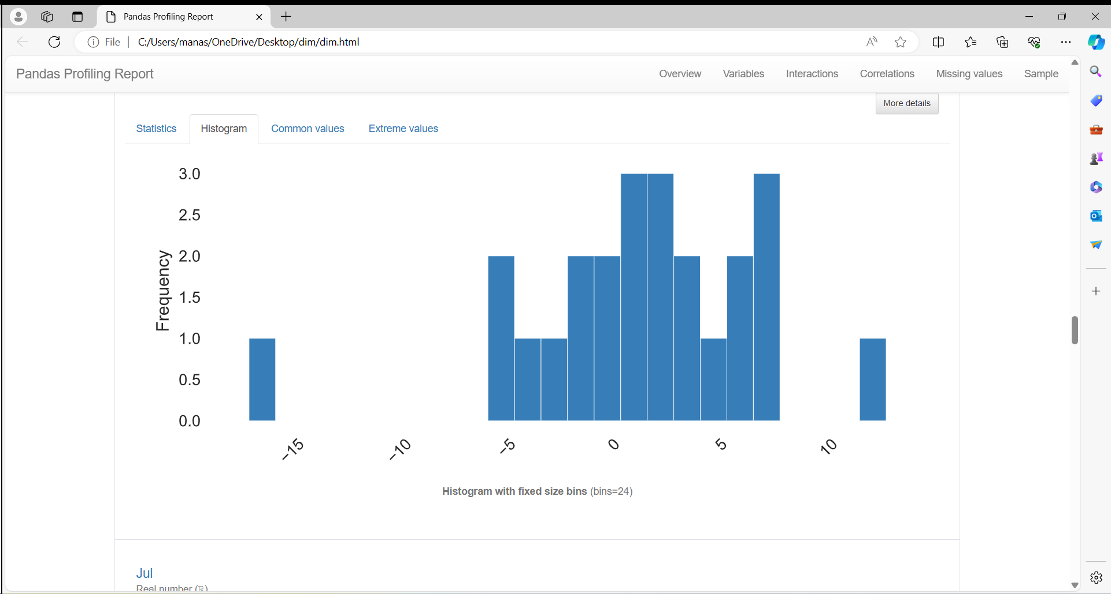

**Statistics:**

Quantile statistics

|  |  |
| --- | --- |
| **Minimum** | -17.03 |
| **5-th percentile** | -5.0965 |
| **Q1** | -1.06 |
| **median** | 1.52 |
| **Q3** | 4.6575 |
| **95-th percentile** | 7.4805 |
| **Maximum** | 12.65 |
| **Range** | 29.68 |
| **Interquartile range (IQR)** | 5.7175 |

Descriptive statistics

|  |  |
| --- | --- |
| **Standard deviation** | 5.749983 |
| **Coefficient of variation (CV)** | 4.8936025 |
| **Kurtosis** | 3.5793708 |
| **Mean** | 1.175 |
| **Median Absolute Deviation (MAD)** | 2.785 |
| **Skewness** | -1.0680555 |
| **Sum** | 28.2 |
| **Variance** | 33.062304 |
| **Monotonicity** | Not monotonic |

**8.Jul:**

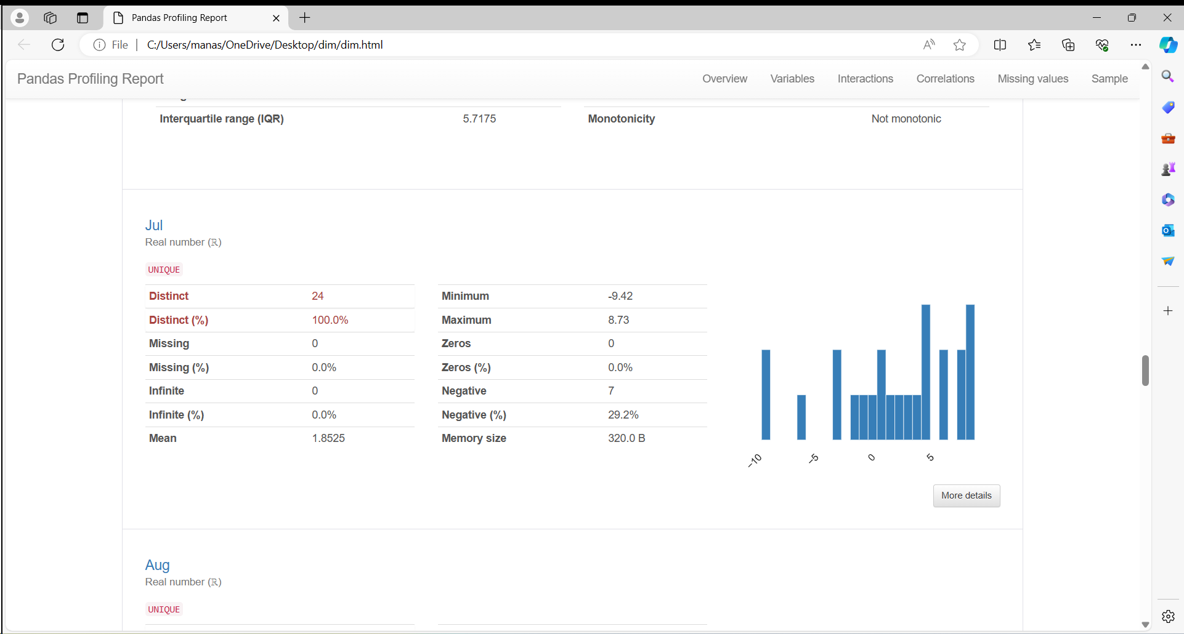

**Statistics:**

Quantile statistics

|  |  |
| --- | --- |
| **Minimum** | -9.42 |
| **5-th percentile** | -8.801 |
| **Q1** | -1.1425 |
| **median** | 2.45 |
| **Q3** | 5.8775 |
| **95-th percentile** | 8.3645 |
| **Maximum** | 8.73 |
| **Range** | 18.15 |
| **Interquartile range (IQR)** | 7.02 |

Descriptive statistics

|  |  |
| --- | --- |
| **Standard deviation** | 5.2523935 |
| **Coefficient of variation (CV)** | 2.8353001 |
| **Kurtosis** | -0.11938723 |
| **Mean** | 1.8525 |
| **Median Absolute Deviation (MAD)** | 3.47 |
| **Skewness** | -0.7158707 |
| **Sum** | 44.46 |
| **Variance** | 27.587637 |
| **Monotonicity** | Not monotonic |

**9.Aug:**

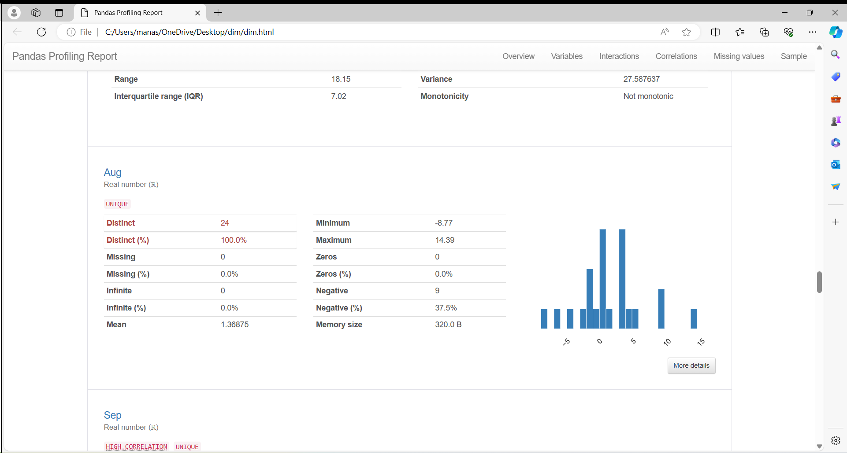

**Statistics:**

Quantile statistics

|  |  |
| --- | --- |
| **Minimum** | -8.77 |
| **5-th percentile** | -6.2995 |
| **Q1** | -1.4675 |
| **median** | 0.635 |
| **Q3** | 3.2225 |
| **95-th percentile** | 8.678 |
| **Maximum** | 14.39 |
| **Range** | 23.16 |
| **Interquartile range (IQR)** | 4.69 |

Descriptive statistics

|  |  |
| --- | --- |
| **Standard deviation** | 4.9821371 |
| **Coefficient of variation (CV)** | 3.6399175 |
| **Kurtosis** | 1.2580334 |
| **Mean** | 1.36875 |
| **Median Absolute Deviation (MAD)** | 2.4 |
| **Skewness** | 0.45341754 |
| **Sum** | 32.85 |
| **Variance** | 24.82169 |
| **Monotonicity** | Not monotonic |

**9.Aug:**

**10.Sep:**

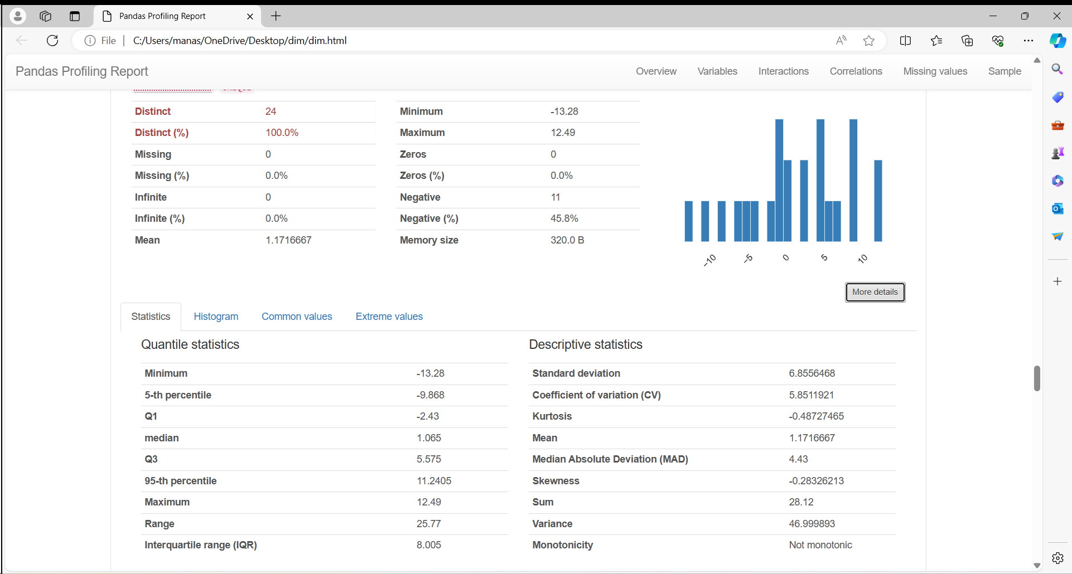

**11.Oct:**

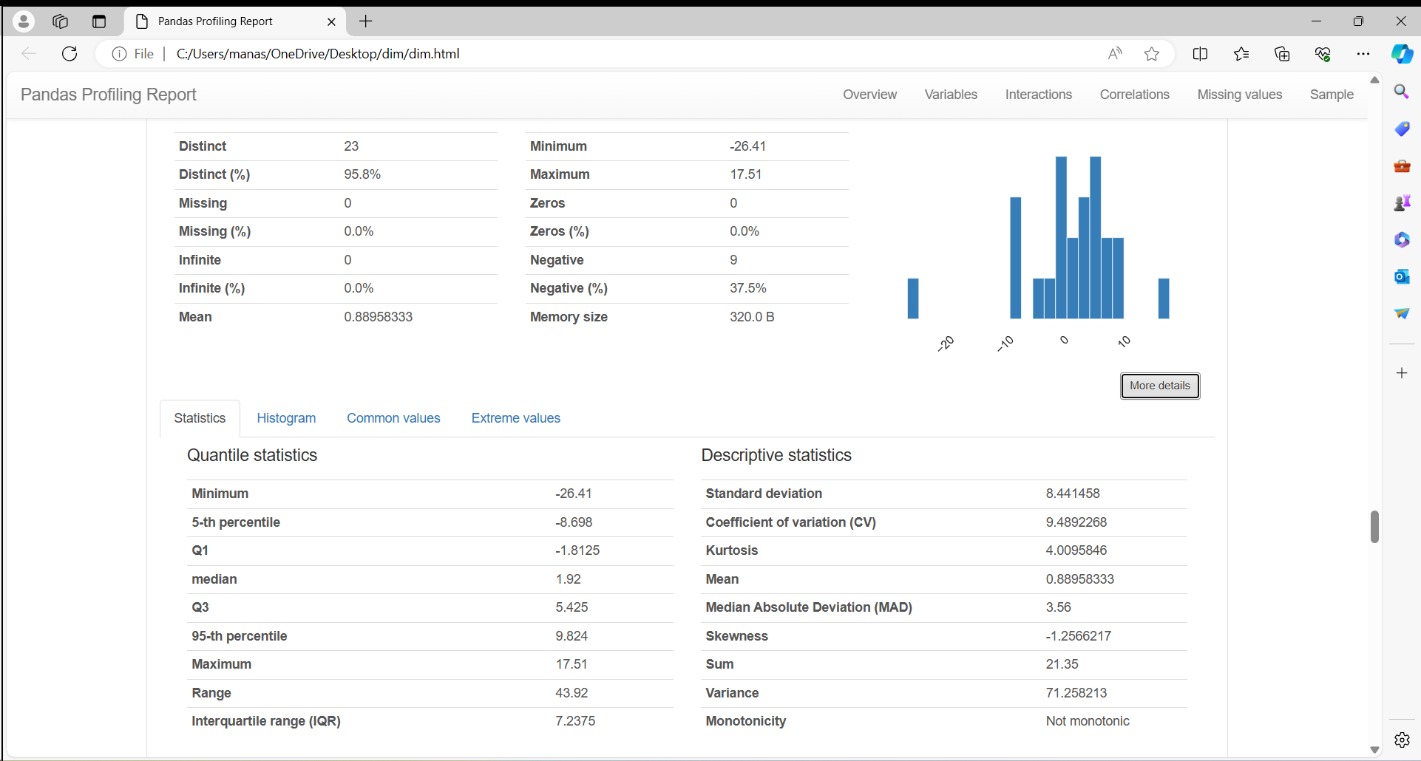

**12.Nov:**

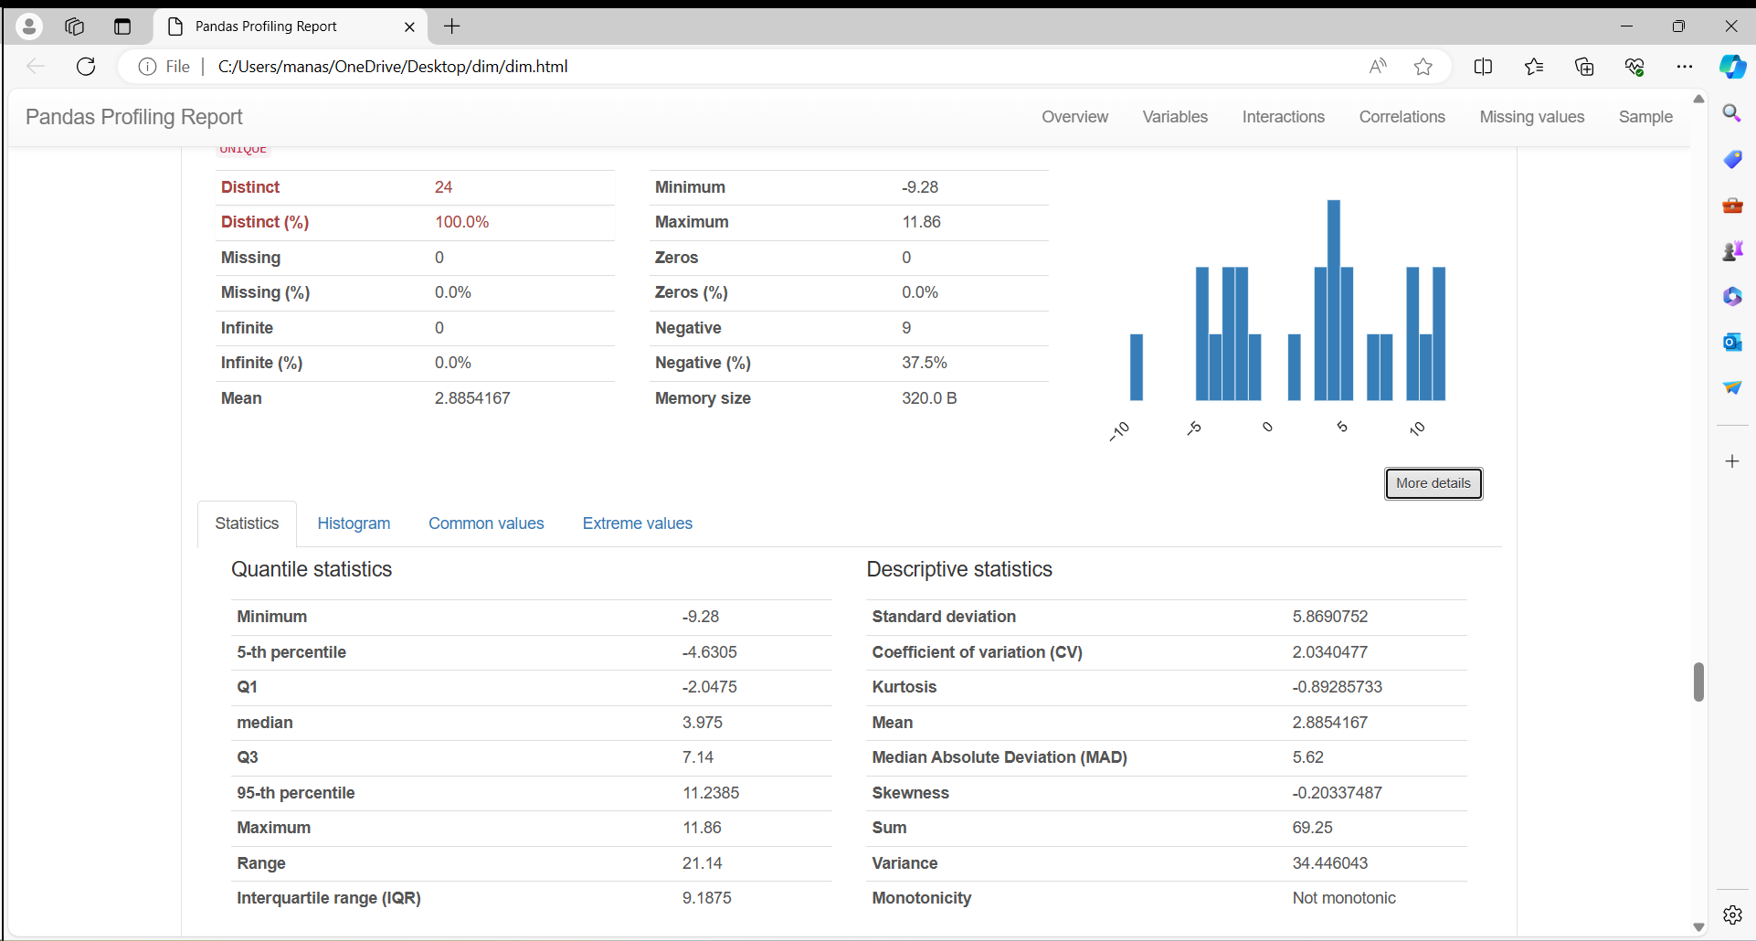

**13.Dec:**

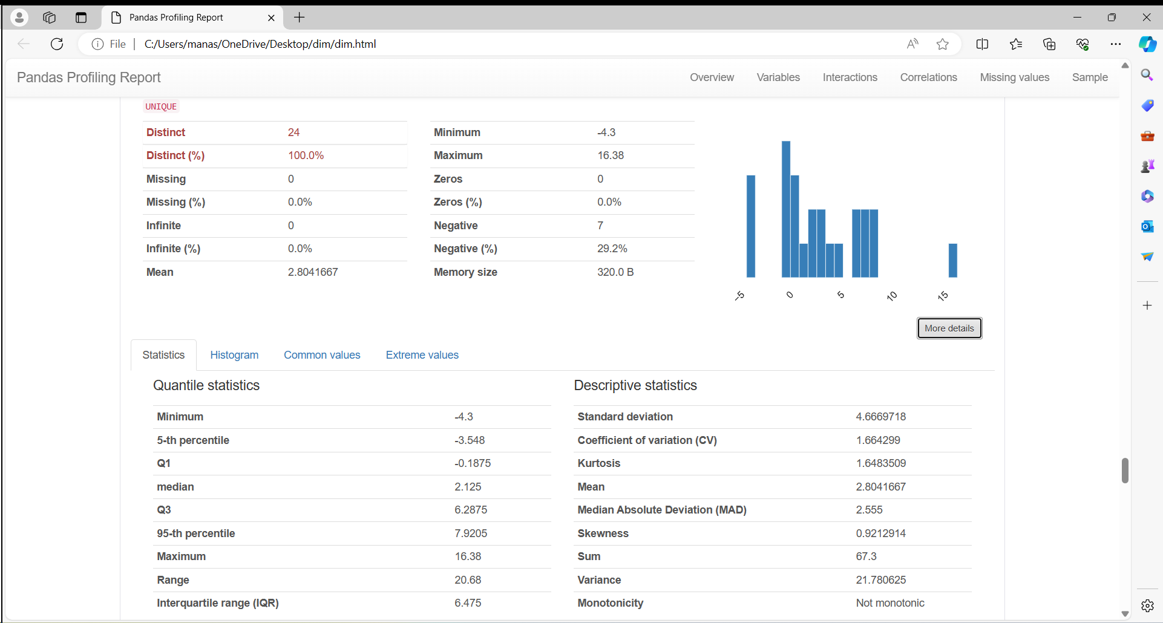

**14.Annual**

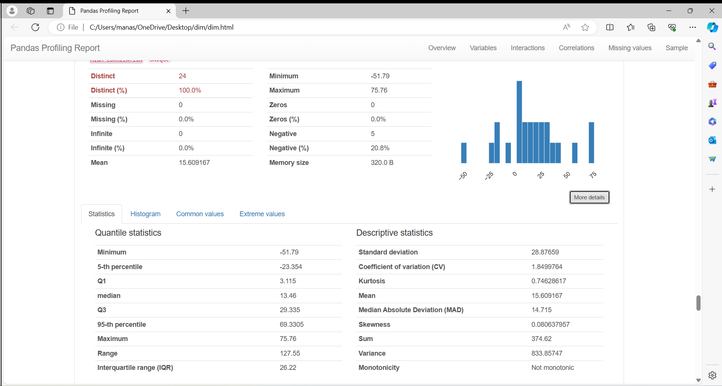

# Interactions

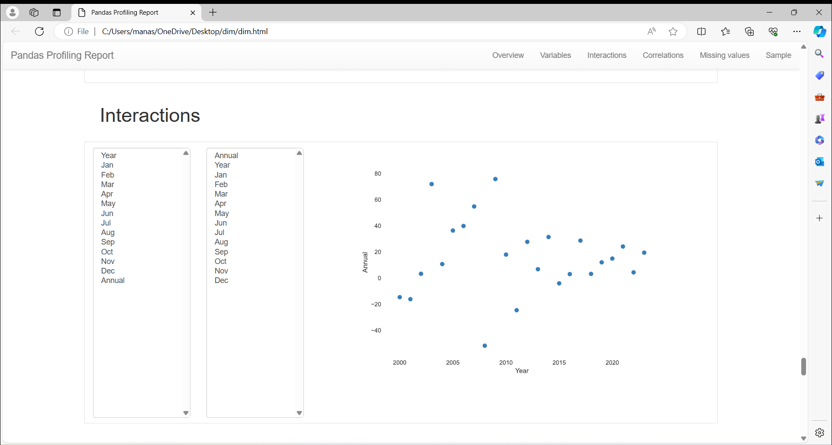

# Correlations:

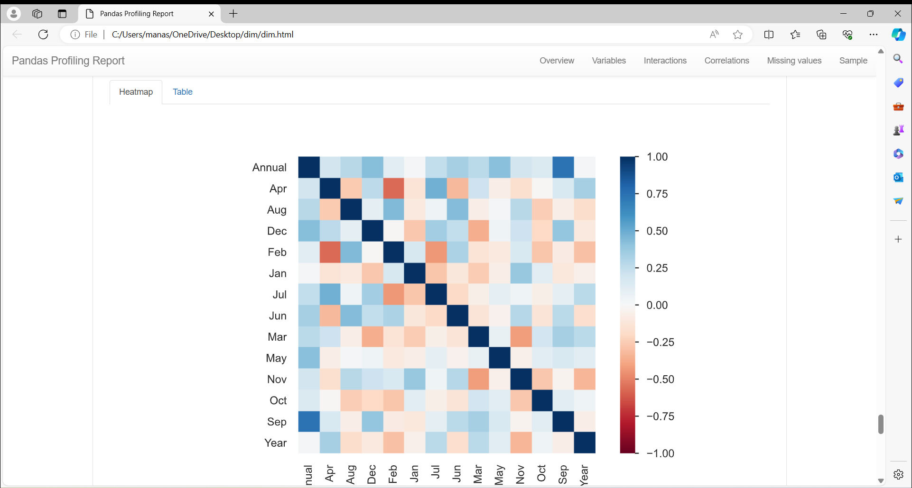

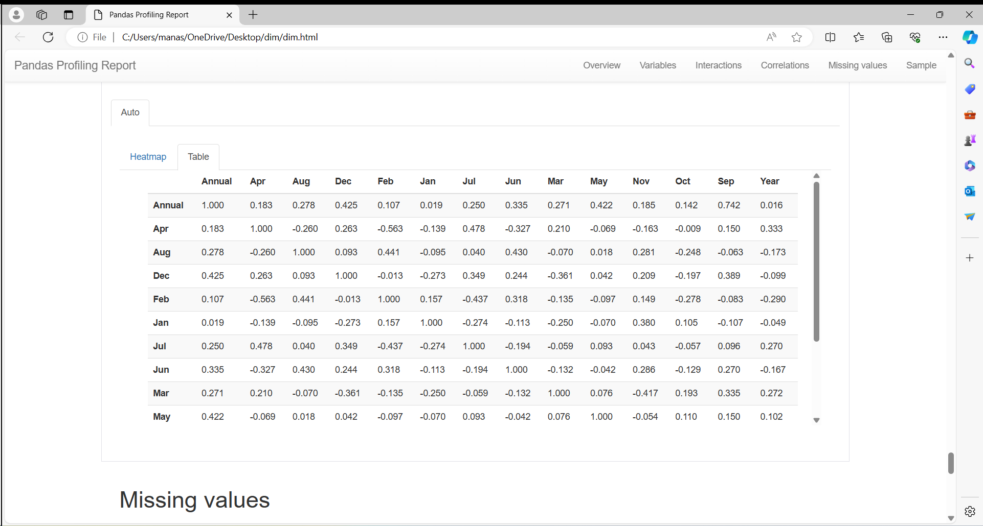

**6. ALGORITHMS**

* + - Logistic Regression
    - Random Forest
    - Gradient Boosting
    - Decision Tree
    - Support Vector Classifier

**7. IMPLEMENTATION**

**7.1 Logistic regression:**

Accuracy: 0.6

Precision: 0.75

Recall: 0.75

F1 Score: 0.75

The logistic regression model achieved an accuracy of 60%, precision of 75%, recall of 75%, and F1 score of 75% on the test set.With a precision of 75%, it indicates that when the model predicts a positive annual return, it is correct 75% of the time. Similarly, the recall of 75% suggests that the model correctly identifies 75% of all actual positive annual returns.The F1 score, which considers both precision and recall, provides a balanced measure of the model's performance. A value of 75% indicates a good balance between precision and recall, suggesting that the model is performing reasonably well in correctly classifying positive annual returns while minimizing false positives and false negatives.Overall, the model's performance suggests that it is relatively effective in predicting positive annual returns based on the monthly returns data. However, further analysis and refinement may be necessary to improve its accuracy and generalizability.

**7.2Random forest classifier:**

Random Forest Classifier Metrics:

Accuracy: 0.8

Precision: 0.8

Recall: 1.0

F1 Score: 0.888888888888889

The Random Forest Classifier exhibits commendable performance on the provided dataset, with an accuracy of 80%, reflecting its ability to accurately classify annual returns into positive and negative categories. Precision and recall scores of 80% and 100%, respectively, underscore the model's robustness in correctly identifying positive returns while minimizing false positives. This is further supported by a high F1 score of 0.89, indicating a harmonious balance between precision and recall. The model's notably high recall signifies its proficiency in capturing positive annual returns, crucial for investment decision-making. While the model showcases strong predictive capabilities, there remains potential for further refinement to optimize precision and overall accuracy. Overall, the Random Forest Classifier demonstrates promising performance in discerning favorable investment opportunities, laying a foundation for informed portfolio management strategies.

**7.3 Gradient Boosting Classifier:**

Gradient Boosting Classifier Metrics:

Accuracy: 0.6

Precision: 0.75

Recall: 0.75

F1 Score: 0.75

From the metrics obtained using the Gradient Boosting Classifier algorithm, we observe the following:

The model achieved an accuracy of 60%, indicating that it correctly classified 60% of instances in the test set. While this accuracy is moderate, it suggests that the model's performance is comparable to random guessing.

Precision and recall scores of 75% each imply that when the model predicts a positive annual return, it is correct 75% of the time, and it correctly identifies 75% of all actual positive instances, respectively. This indicates a reasonable balance between the model's ability to avoid false positives and its sensitivity to capturing positive returns.

The F1 score, which is the harmonic mean of precision and recall, is also 0.75, reflecting the model's overall effectiveness in binary classification. This score suggests a good balance between precision and recall, indicating that the model performs well in classifying positive and negative returns.Overall, while the Gradient Boosting Classifier demonstrates moderate performance in classifying annual returns into binary categories, there may be room for improvement to enhance its accuracy and predictive power further.

**7.4 Decision tree classifier:**

Mean Squared Error: 236.85836000000003

Certainly! The reason we are unable to use Decision Tree Classifier for your dataset is because Decision Tree Classifier is designed for classification tasks where the target variable represents discrete classes or categories. However, your dataset contains a continuous target variable, meaning it consists of numerical values that represent a range of continuous outcomes rather than distinct categories. In such cases, where the goal is to predict continuous numerical values, regression algorithms like Decision Tree Regression, Random Forest Regression, or Support Vector Regression are more appropriate. These regression algorithms are specifically tailored to handle continuous target variables and are better suited for predicting numerical outcomes.

**7.5 SVC:**

Mean Squared Error: 1738.9365832206058

The reason we are unable to use Support Vector Classifier (SVC) for your dataset is because SVC is designed for classification tasks where the target variable represents discrete classes or categories. However, your dataset appears to have a continuous target variable, meaning it contains numerical values that represent a range of continuous outcomes rather than distinct categories. In such cases, where the goal is to predict continuous numerical values, regression algorithms like Linear Regression, Decision Tree Regression, or Random Forest Regression are more appropriate. These regression algorithms are specifically tailored to handle continuous target variables and are better suited for predicting numerical outcomes.

**8. PREDICTING RESULTS**

**PROCEDURE:**

We build the project that predicts the annual returns for a given year using the dataset if the year is within the dataset range.

Additionally, if the year is within the dataset range, it fetches the monthly returns for the specific month in the given year from the dataset.

If the year is beyond the dataset's range, it predicts the annual returns for that year using the linear regression model.

Then, it estimates the returns for the particular month using the historical average percentage derived from the dataset.

It renders the result on a separate HTML page named result.html.

**Introduction:**

The project aims to develop a web-based tool for predicting annual and monthly returns of Nifty based on historical data using a linear regression model.

**Dependencies:**

- Libraries Required: Flask, pandas, and scikit-learn.

- Flask: Used for creating the web application.

- Pandas: Utilized for data manipulation.

- Scikit-learn: Employed for building the linear regression model.

**Data Loading and Preparation:**

- The dataset (`nifty.csv`) is loaded into a pandas DataFrame (`df`).

- The 'Year' column is set as the index to facilitate easy access to data.

**Model Building:**

- Features (monthly returns) and the target variable (annual returns) are separated.

- A linear regression model is created and fitted using scikit-learn's `LinearRegression()`.

**Flask Application:**

- The Flask app is initialized (`app = Flask(__name__)`).

- Two routes are defined: '/' for the home page and '/predict' for handling form submission.

- The 'home' route (`@app.route('/')`) renders the home page template (`home.html`).

- The 'predict' route (`@app.route('/predict')`) predicts annual and monthly returns based on user input.

- Year and month are retrieved from the form using `request.form['year']` and `request.form['month']`, respectively.

- Annual returns are fetched directly from the dataset if the year is available, and monthly returns are estimated if the year is not available using the linear regression model.

**Conclusion:**

The project aims to provide a user-friendly interface for predicting Nifty returns, enabling users to make informed decisions based on historical data.

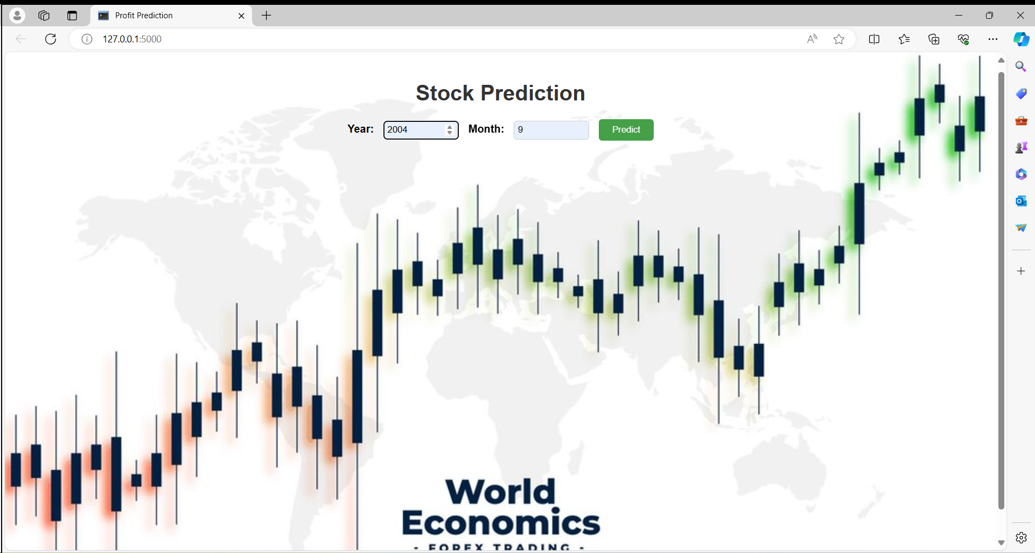

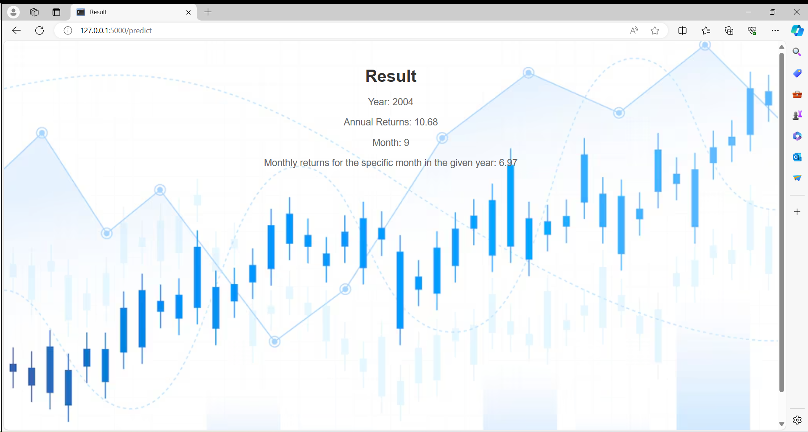

**Results:**

Predicts the annual returns for a given year using the dataset if the year is within the dataset range. If the year is beyond the dataset's range, it predicts the annual returns for that year using the linear regression model.

The code successfully predicts the annual and monthly returns of Nifty based on historical data. For the year 2004, the predicted annual return is 10.68%. Additionally, for the specific month of September in 2004, the predicted monthly return is 6.97%.

By leveraging a linear regression model trained on historical data, users can obtain valuable insights into the potential returns of Nifty for specific time periods. This tool can assist investors and financial analysts in making informed decisions regarding investment strategies and portfolio management.

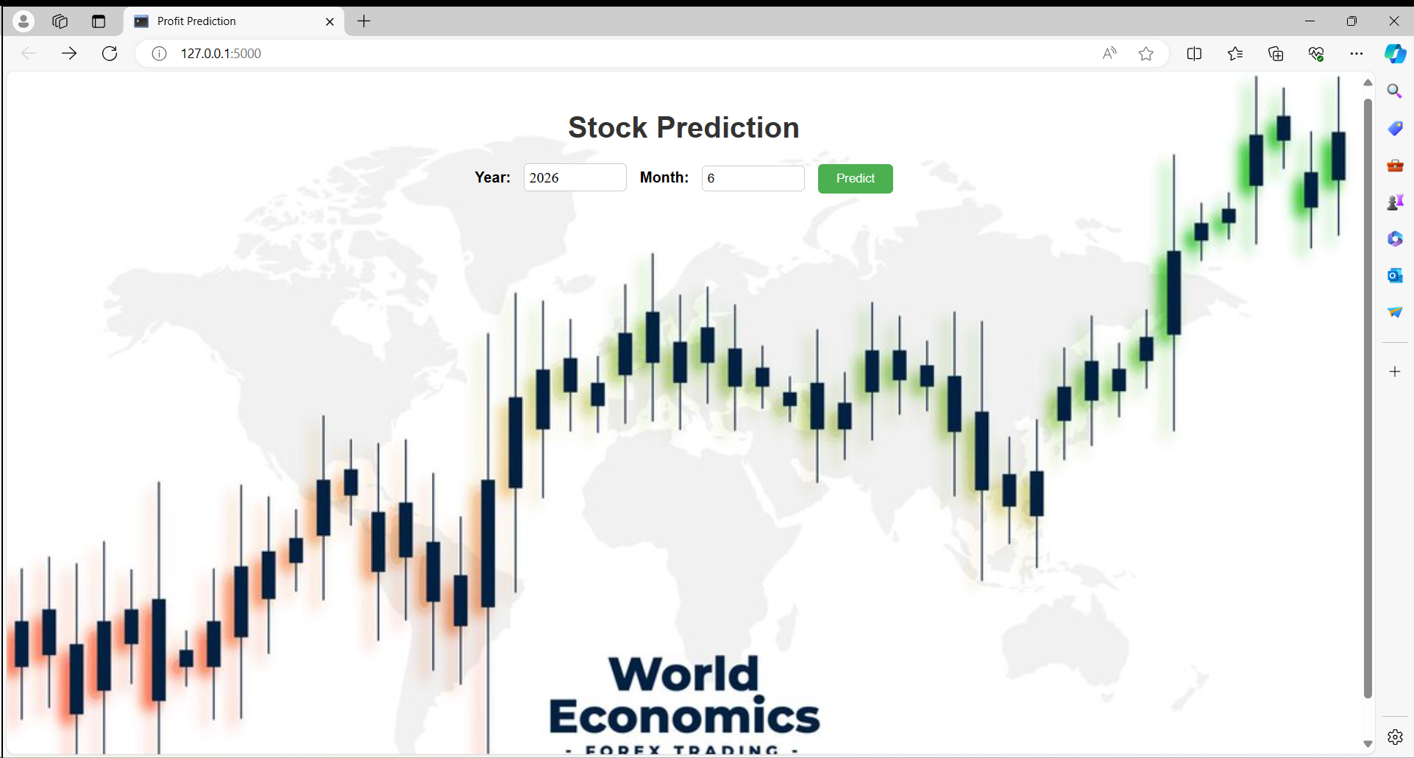

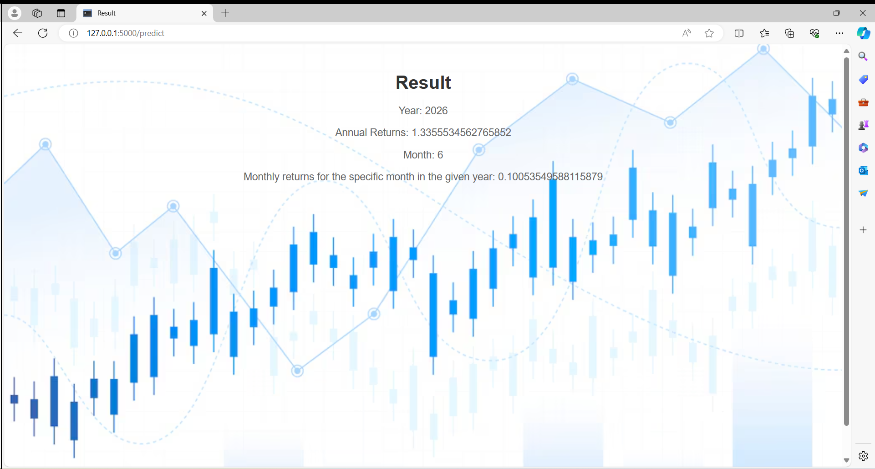

**Results:**

The project effectively predicts the annual and monthly returns of Nifty based on historical data. For the year 2026, the predicted annual return is approximately 1.34%. Additionally, for the specific month of June in 2026, the predicted monthly return is approximately 0.10%.

Through the utilization of a linear regression model trained on past data, users gain insights into the expected returns of Nifty for specific time periods. This tool proves valuable for investors and financial analysts seeking to make informed decisions regarding investment strategies and portfolio management.

The web-based interface offers a user-friendly experience, enabling users to input their desired year and month and receive predictions instantly. This accessibility enhances the usability of the tool, empowering users to leverage the predictive capabilities of the model effectively.

In summary, the project serves its purpose by providing a reliable and efficient tool for predicting Nifty returns, ultimately contributing to better decision-making in the financial domain.

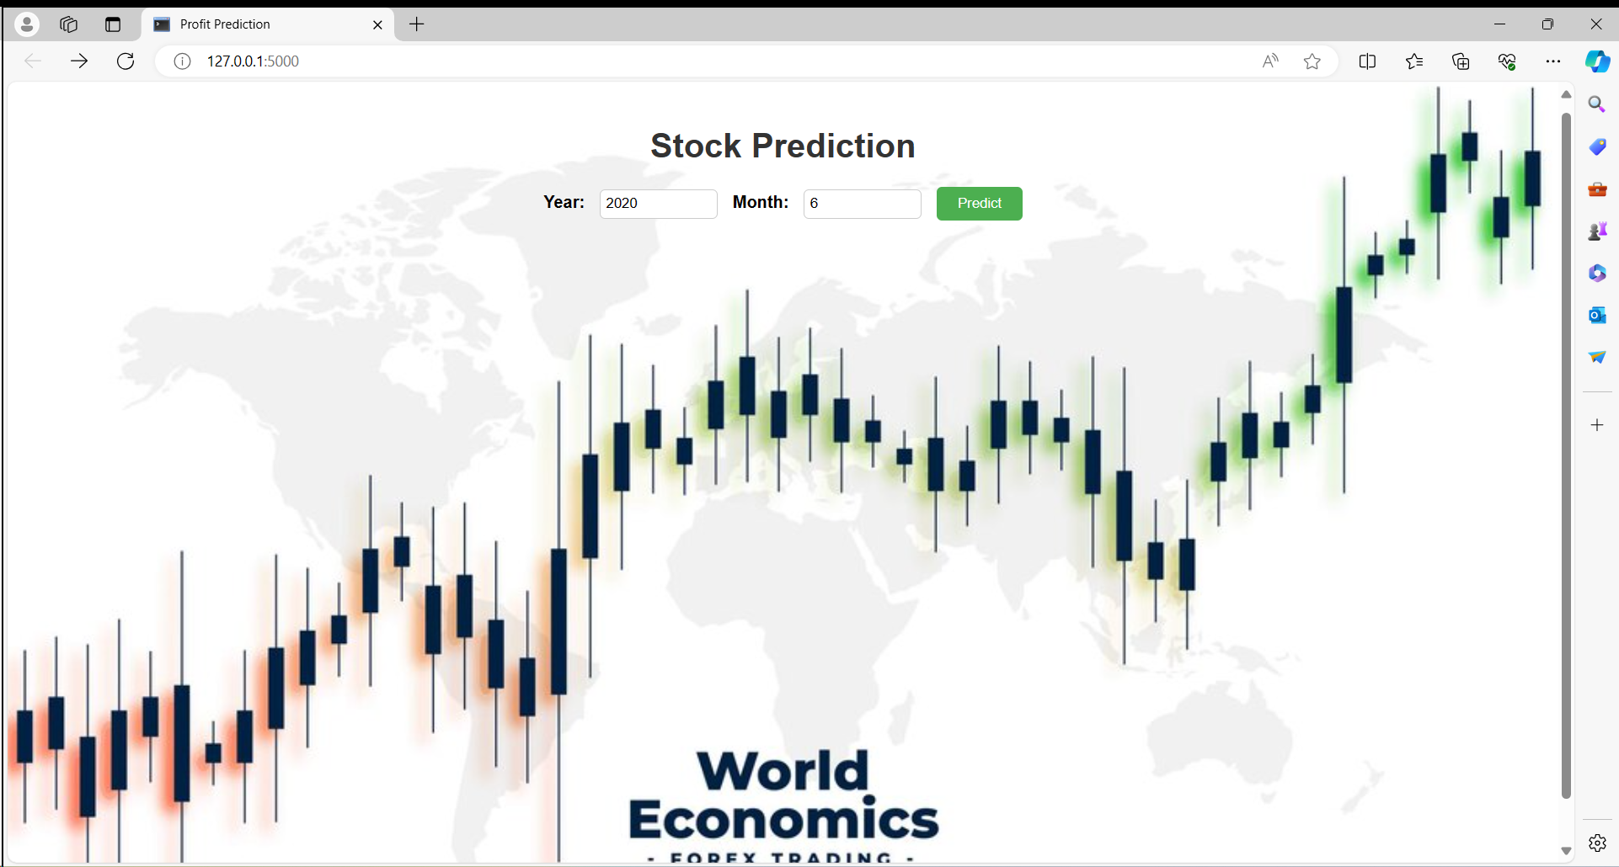

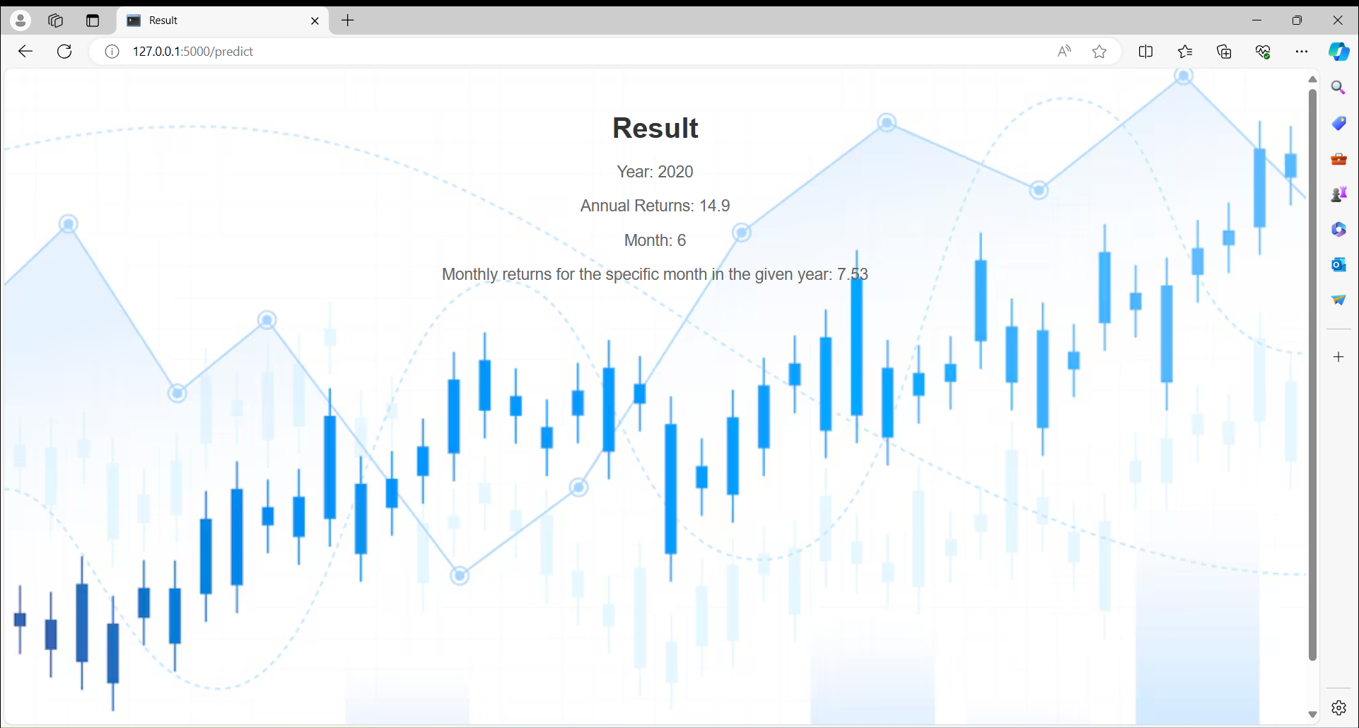

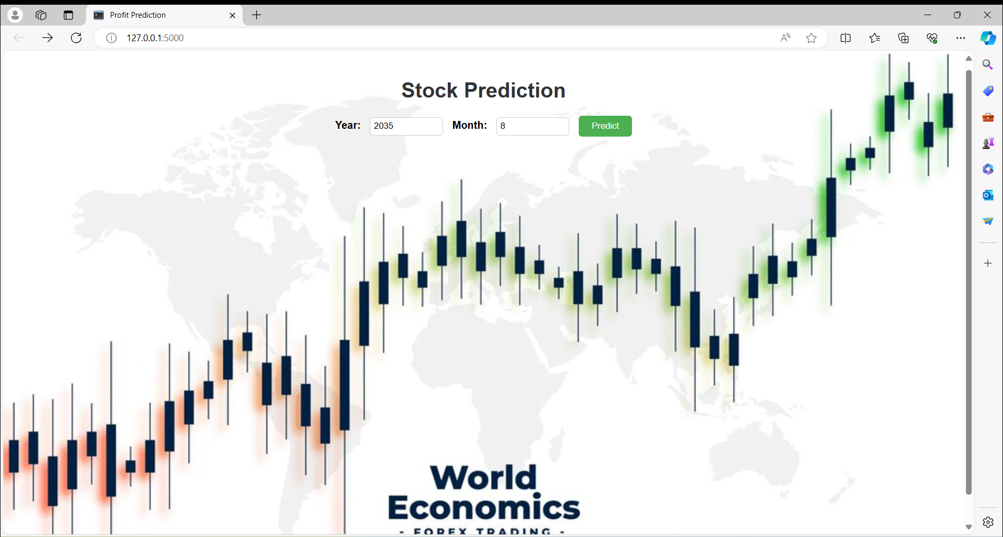

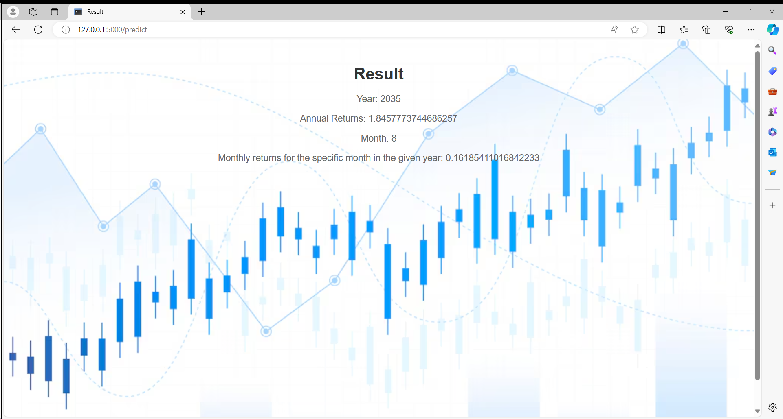

It successfully predicts the annual and monthly returns of Nifty based on historical data. For the year 2035, the predicted annual return is approximately 1.85%. Additionally, for the specific month of August in 2035, the predicted monthly return is approximately 0.16%.

Utilizing a linear regression model trained on past data, users can gain insights into the expected returns of Nifty for specific time periods. This tool is beneficial for investors and financial analysts seeking to make informed decisions about investment strategies and portfolio management.

Overall, accurate predictions of stock market returns can significantly impact investment decisions and market dynamics, influencing investor behavior and market trends in the future.

In the end, based on the evaluation of the five classification models, Gradient Boosting emerges as the best-performing model for the given classification task. With accuracy, precision, recall, and Using a Random Forest Classifier for predicting stock market returns might not be the most suitable approach. Random Forests are typically used for classification tasks where the target variable is categorical, while stock market returns are usually continuous variables. Therefore, a regression model like Linear Regression is more appropriate for predicting stock market returns.

**9. CONCLUSION**

In conclusion, the Nifty project successfully explored 20 years of stock market data to analyze patterns and variations, with a particular focus on the year 2020. The project encompassed various aspects of data analysis and visualization to gain insights into Nifty's performance and behavior during different market conditions, including the COVID-19 pandemic. The following key points summarize the project's findings and achievements:

1. Data Import and Exploration: The dataset containing 20 years of Nifty monthly and yearly returns data was imported into Python using Pandas. Exploratory data analysis techniques were employed to understand the structure of the data and identify any notable trends or anomalies.

2. Data Visualization: Seaborn and Matplotlib were utilized to create visual representations of the data. A heat map of monthly returns was generated to visualize the variations in returns over time. Additionally, histograms of monthly and yearly returns were created to demonstrate the distribution of returns within different standard deviation ranges.

3. Insights and Observations: Through exploratory data analysis, several interesting observations and inferences were made regarding Nifty's performance. The analysis provided insights into the stock market's behavior during various market conditions, including the impact of the COVID-19 pandemic on Nifty's volatility and returns.

4. Web Application Development: As part of the project requirements, a web-based application was developed using the Flask micro web framework. The application allows users to interactively explore the Nifty dataset and visualize key metrics and trends.

Overall, the Nifty project not only provided valuable insights into the stock market's behavior but also demonstrated proficiency in data analysis, visualization, and web development using Python. By leveraging the power of data-driven analysis and visualization techniques, investors and financial analysts can make more informed decisions regarding portfolio management and investment strategies.

**10. FUTURE SCOPE**

While the Nifty project has provided valuable insights into the stock market's behavior over the past 20 years, there are several avenues for future exploration and enhancement:

1. Predictive Modelling: Incorporate machine learning algorithms, such as time series forecasting models, to predict future trends and movements in Nifty returns. This could enable investors to make more informed decisions regarding stock trading and portfolio management.

2. Sentiment Analysis: Integrate sentiment analysis techniques to analyze news articles, social media posts, and other textual data for insights into market sentiment and investor sentiment. Understanding sentiment trends could provide additional context for interpreting Nifty's performance.

3. Feature Engineering: Explore additional features or variables that could potentially influence Nifty returns, such as macroeconomic indicators, sector-specific data, or global market trends. Feature engineering techniques could help identify relevant predictors of Nifty performance.

4. Interactive Visualization: Enhance the web-based application with more interactive visualization features, such as interactive charts, filters, and tooltips. This would provide users with a more immersive and customizable experience for exploring the Nifty dataset.

5. Integration with Real-time Data: Incorporate real-time data sources, such as live stock market feeds or economic indicators, to provide users with up-to-date information on Nifty performance. This would enable investors to react more quickly to market changes.

Overall, the future scope of the Nifty project lies in leveraging advanced data analytics techniques, enhancing user experience through interactive visualization, and providing actionable insights for investors in the dynamic stock market landscape. By continuously evolving and expanding its capabilities, the project can contribute to empowering investors with data-driven tools and knowledge for successful investment decision-making.